ABSTRACT

The purpose of this project is to offer hardware and software implementation for data transfer in a car between some electronic parts using the Controller Area Network protocol. We were inspired by the new Ford Mondeo car and our intention was to build an equivalent embedded system to control mirrors, windows, seat positions, doors, and other components while this system is an open framework. Major international automakers have considered the deployment of the 5.9 GHz Dedicated Short-Range Communications (DSRC) on their vehicle fleets for wireless connectivity. DSRC enabled Vehicle-to-Vehicle (V2V) communication through broadcast of Basic Safety Messages (BSMs) enables safety applications for crash warning and avoidance.
However, in dense traffic conditions as the V2V deployment scales up, the resultant channel load increases and leads to channel congestion and may adversely affect the performance of the safety applications. The Society of Automotive Engineers (SAE) J2945/1 standard that builds a top Institute of Electrical and Electronics Engineers (IEEE) 802.11P and IEEE 1609 standards provides the minimum performance requirements (MPR) for V2V safety communications. Specifically, it provides a Congestion Control (CC) protocol for transmission rate and power adaptations to achieve robust performance in dense vehicular networks. The primary contribution of this Project is that using a congestion generation test bed that emulates channel congestion including a large number of Remote Vehicles (RVs), we can validate and test any V2V equipped vehicle for compliance with the J2945/1 standard. Our project also demonstrates that under heavy congestion, even with 600 ms of inter-transmit time (ITT), a moving vehicle can be tracked to lane-level accuracy
INTRODUCTION
Major international automakers have considered the deployment of the 5.9 GHz Dedicated Short-Range Communications (DSRC) on their vehicle fleets for wireless connectivity. DSRC-enabled Vehicle-to-Vehicle (V2V) communication through broadcast of Basic Safety Messages (BSMs) enables safety applications for crash warning and avoidance. However, in dense traffic conditions as the V2V deployment scales up, the resultant channel load increases and leads to channel congestion and may adversely affect the performance of the safety applications. The Society of Automotive Engineers (SAE) J2945/1 standard that builds atop Institute of Electrical and Electronics Engineers (IEEE) 802.11p and IEEE 1609 standards provides the minimum performance requirements (MPR) for V2V safety communications. Specifically, it provides a Congestion Control (CC) protocol for transmission rate and power adaptations to achieve robust performance in dense vehicular networks. The primary contribution of this paper is that using a congestion generation testbed that emulates channel congestion including a large number of Remote Vehicles (RVs), we can validate and test any V2V equipped vehicle for compliance with the J2945/1 standard. Our paper also demonstrates that under heavy congestion, even with 600 ms of inter-transmit time (ITT), a moving vehicle can be tracked to lane-level accuracy.
Major U.S., European, and Japanese automakers such as General Motors, Volkswagen, and Toyota have recently either equipped some of their production vehicles with Dedicated Short Range Communications (DSRC) systems or plan to do so [1]–[3]. The U.S. Department of Transportation (USDOT) issued in January 2017 a Notice for Proposed Rule-Making (NPRM) with the eventual aim of mandating the deployment of Vehicle-to-Vehicle (V2V) safety communication based on DSRC on all new light vehicles sold in the United States. The DSRC-based V2V technology is an outcome of nearly 15 years of efforts of the industry, academia, and the government. The DSRC-based V2V system builds atop several Institute of Electrical and Electronics Engineers (IEEE) and Society of Automotive Engineers (SAE) standards towards connected vehicles technology for safety and crash avoidance applications Such safety applications are based on V2V safety communication that includes broadcast of vehicle status information through Basic Safety Messages (BSMs). The BSMs include core state information such as Global Navigation Satellite System (GNSS) location, speed, acceleration, brake status, and path history [4] [5], with communication ranges of 400-500 meters, or more. In particular, such V2V systems use the SAE J2945/1 standard [6] that is based on several IEEE and SAE standards: • The Medium Access Control (MAC) and Physical Layer (PHY) protocol follow the IEEE 802.11p standard. The Federal Communications Commission (FCC) has dedicated 75 MHz of spectrum in the 5.9 GHz band for communication between vehicles (V2V) and between vehicles and roadside infrastructure (V2I). • The BSMs follow the Wireless Access in Vehicular Environments (WAVE) Short Message (WSM) using the WAVE Short Message Protocol (WSMP) as defined in the IEEE 1609.3 standard. • The BSM security is based upon compliance to the security certification as per the IEEE 1609.2 standard. It includes digital signatures along with security certificates or certificate digests to validate the sender’s BSMs. • The WAVE Provider Service ID (PSID) of the BSMs is defined as per the IEEE 1609.12 standard and is used to distinguish between DSRC messages. • The message data dictionary, content and format of a BSM is as per the SAE J2735 standard. The J2945/1 V2V standard, published in 2016, provides a set of minimum performance requirements (MPR) for V2V communication to support safety applications for crash warning and avoidance [7].
In particular, detailed performance requirements are specified to ensure the accuracy of GNSS position, speed, heading, acceleration, and yaw rate among other factors with respect to ground truth. In a high traffic environment, where there is a high number of vehicles (transmitters), the channel suffers congestion due to rising interference and channel contention [8]. When it comes to channel capacity, [9] presented some fundamental limits especially as a wireless network scales. The conventional approach to handle interference in the IEEE 802.11p standard is to use Carrier-Sense Multiple Access with Collision Avoidance (CSMA/CA) as the medium access protocol [10]. In CSMA/CA, when a node (or vehicle) has a packet to transmit it first listens to the channel. If the channel is deemed idle or unoccupied, it transmit the packet. Otherwise, the node waits for a random back-off time before transmitting the packet. While this mechanism reduces the chances of packet collisions, it does not avoid it entirely. In large and dense V2V networks, the performance of safety applications may therefore unnecessarily suffer if all vehicles send their BSMs at the same high transmission rate and transmit power. The consequent high packet losses affect V2V situational awareness and make it difficult to predict a vehicle’s movement or recognize an imminent crash in a timely manner. Hence, mitigating the channel congestion has been widely studied to address the challenge of scalability and to make the safety applications robust. The authors in [11] have shown that communication and safety performance degrades significantly in a congested environment without a congestion control mechanism. In [13], a distributed transmit power control method is proposed, which reduces the power of safety message transmissions during congestion in order to control the load placed on the DSRC channel. In [14], a message rate control based approach is proposed to adapt the BSM transmission rate (frequency) based on a binary comparison between measured channel load and a target threshold. Binary message rate control is also the subject of [11], in which the authors propose using an Additive Increase Multiplicative Decrease (AIMD) message rate update mechanism for DSRC vehicular safety communication. They present results from prototype radio tests and computer simulations that illustrate effective message rate control for hundreds of emulated or simulated vehicles. The authors in [15] present simulation of two popular rate algorithms (ONOE and AARF) and compare the performance with different metrics. In [16], the authors propose an algorithm to minimize the average system information age in a congested environment. Through the simulations, they also show that simple contention window size adaptations (i.e. increasing or decreasing the window size) are unsuitable for reducing the information age.
The authors in [13], propose a distributed transmit power control method which helps reduce BSM load and thus reserves bandwidth for emergency messages with higher priorities. All these factors and considerations have been merged in the SAE J2945/1 standard which provides a congestion control (CC) protocol that adapts the transmit power and rate control of V2V BSM transmissions in order to achieve satisfactory safety performance. The CC protocol executes distributed on each DSRC-equipped On-board Equipment (OBE) installed in a vehicle and adapts its radiated (transmit) power and the Inter-Transmit Time (ITT) based on the channel congestion levels the OBE experiences locally. The underlying algorithm is designed to be opportunistic to ensure channel utilization remains below the saturation level while V2V safety applications can have a good performance. The authors in [17] review the CC protocol presented in the J2945/1 standard and propose a testing methodology for its primary functions. In [18], this standard is also evaluated in a simulation environment in terms of packet error rate and information age. Contributions: This paper presents on DSRC-based V2V system congestion control validation and performance through vehicle-level testing. The development was done under the V2V Systems Engineering Project conducted by the Crash Avoidance Metrics Partners (CAMP) LLC under a cooperative agreement with the National Highway Traffic Safety Administration (NHTSA). The CAMP VSC6 Consortium consists of Ford Motor Company, General Motors LLC, Honda R&D Americas Inc, Hyundai-Kia America Technical Center, Nissan Technical Center North America and Volkswagen Group of America. We present the congestion control validation of a V2V DSRC-enabled OBE installed in a vehicle that complies with the J2945/1 standard. In our congestion control testbed, we use a DSRC-enabled Host Vehicle (HV) to wirelessly transmit BSMs, a Ground Truth Equipment (GTE) mounted on the HV to accurately capture its position and a DSRC sniffer to remotely capture the BSMs received over-the-air (OTA). Furthermore, we used a Congestion Generation Tool (CGT) that can emulate up to 160 Remote Vehicles (RVs) in our setup (which could be expanded) and up to 80% Channel Busy Percentage (CBP) (i.e., a measure of channel occupancy) by transmitting a mix of BSM and WSM packets. We conducted multiple test runs where the HV was stationary or performed various kinds of dynamic maneuvers (such as sharp maneuvers or hard braking).
The DSRC-enabled HV used a local GNSS unit for real-time positioning. Such tests were performed under specified congestion levels in the background to reproduce CBP and emulated RVs that are representative of actual traffic conditions. Our tests validated that the DSRC-enabled vehicle can adapt its ITT and transmit power to real-world factors. Specifically, for a moving vehicle, we show that even with 600 ms between BSMs, an RV can track the HV to within 1.5m of its ground truth position. This result is particularly important as it shows that even with congestion in the background, vehicles can meet the J2945/1 position requirement for safety applications.
INTRODUCTION TO EMBEDDED SYSTEMS
2.1 EMBEDDED SYSTEMS
Embedded systems are designed to do some specific task, rather than be a general-purpose computer for multiple tasks. Some also have real time performance constraints that must be met, for reason such as safety and usability; others may have low or no performance requirements, allowing the system hardware to be simplified to reduce costs. An embedded system is not always a separate block - very often it is physically built-in to the device it is controlling. The software written for embedded systems is often called firmware, and is stored in read-only memory or flash convector chips rather than a disk drive. It often runs with limited computer hardware resources: small or no keyboard, screen, and little memory.
Wireless communication has become an important feature for commercial products and a popular research topic within the last ten years. There are now more mobile phone subscriptions than wired-line subscriptions. Lately, one area of commercial interest has been low-cost, low-power, and short-distance wireless communication used for personal wireless networks." Technology advancements are providing smaller and more cost effective devices for integrating computational processing, wireless communication, and a host of other functionalities. These embedded communications devices will be integrated into applications ranging from homeland security to industry automation and monitoring. They will also enable custom tailored engineering solutions, creating a revolutionary way of disseminating and processing information. With new technologies and devices come new business activities, and the need for employees in these technological areas. Engineers who have knowledge of embedded systems and wireless communications will be in high demand. Unfortunately, there are few adorable environments available for development and classroom use, so students often do not learn about these technologies during hands-on lab exercises. The communication mediums were twisted pair, optical fiber, infrared, and generally wireless radio.
An embedded system is a computer system designed to perform one or a few dedicated functions often with real-time computing constraints. It is embedded as part of a complete device often including hardware and mechanical parts. By contrast, a general-purpose computer, such as a personal computer (PC), is designed to be flexible and to meet a wide range of end-user needs. Embedded systems control many devices in common use today. Embedded systems are controlled by one or more main processing cores that are typically either microcontrollers or digital signal processors (DSP). The key characteristic, however, is being dedicated to handle a particular task, which may require very powerful processors. For example, air traffic control systems may usefully be viewed as embedded, even though they involve mainframe computers and dedicated regional and national networks between airports and radar sites. (Each radar probably includes one or more embedded systems of its own.)
Since the embedded system is dedicated to specific tasks, design engineers can optimize it to reduce the size and cost of the product and increase the reliability and performance. Some embedded systems are mass-produced, benefiting from economies of scale. Physically embedded systems range from portable devices such as digital watches and MP3 players, to large stationary installations like traffic lights, factory controllers, or the systems controlling nuclear power plants. Complexity varies from low, with a single microcontroller chip, to very high with multiple units, peripherals and networks mounted inside a large chassis or enclosure.
In general, "embedded system" is not a strictly definable term, as most systems have some element of extensibility or programmability. For example, handheld computers share some elements with embedded systems such as the operating systems and microprocessors which power them, but they allow different applications to be loaded and peripherals to be connected. Moreover, even systems which don't expose programmability as a primary feature generally need to support software updates. On a continuum from "general purpose" to "embedded", large application systems will have subcomponents at most points even if the system as a whole is "designed to perform one or a few dedicated functions", and is thus appropriate to call "embedded". A modern example of embedded system is shown in fig: 2.1. Labeled parts include microprocessor (4), RAM (6), flash memory (7). Embedded systems programming is not like normal PC programming. In many ways, programming for an embedded system is like programming PC 15 years ago. The hardware for the system is usually chosen to make the device as cheap as possible. Spending an extra dollar a unit in order to make things easier to program can cost millions. Hiring a programmer for an extra month is cheap in comparison.
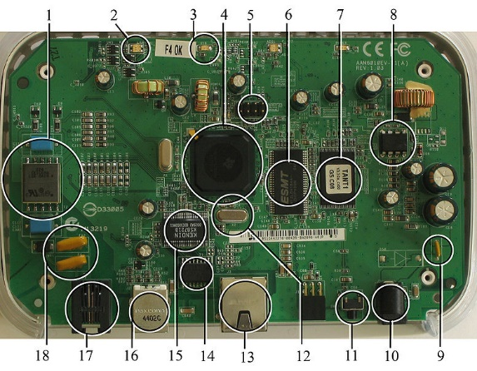
Fig 2.1:A modern example of embedded system
This means the programmer must make do with slow processors and low memory, while at the same time battling a need for efficiency not seen in most PC applications. Below is a list of issues specific to the embedded field.
2.1.1 History:
In the earliest years of computers in the 1930–40s, computers were sometimes dedicated to a single task, but were far too large and expensive for most kinds of tasks performed by embedded computers of today. Over time however, the concept of programmable controllers evolved from traditional electromechanical sequencers, via solid state devices, to the use of computer technology. One of the first recognizably modern embedded systems was the Apollo Guidance Computer, developed by Charles Stark Draper at the MIT Instrumentation Laboratory. At the project's inception, the Apollo guidance computer was considered the riskiest item in the Apollo project as it employed the then newly developed monolithic integrated circuits to reduce the size and weight. An early mass-produced embedded system was the Autonetics D-17 guidance computer for the Minuteman missile, released in 1961. It was built from transistor logic and had a hard disk for main memory. When the Minuteman II went into production in 1966, the D-17 was replaced with a new computer that was the first high-volume use of integrated circuits.
2.1.2 Tools:
Embedded development makes up a small fraction of total programming. There's also a large number of embedded architectures, unlike the PC world where 1 instruction set rules, and the UNIX world where there's only 3 or 4 major ones. This means that the tools are more expensive. It also means that they're lowering featured, and less developed. On a major embedded project, at some point you will almost always find a compiler bug of some sort.
Debugging tools are another issue. Since you can't always run general programs on your embedded processor, you can't always run a debugger on it. This makes fixing your program difficult. Special hardware such as JTAG ports can overcome this issue in part. However, if you stop on a breakpoint when your system is controlling real world hardware (such as a motor), permanent equipment damage can occur. As a result, people doing embedded programming quickly become masters at using serial IO channels and error message style debugging.
2.1.3 Resources:
To save costs, embedded systems frequently have the cheapest processors that can do the job. This means your programs need to be written as efficiently as possible. When dealing with large data sets, issues like memory cache misses that never matter in PC programming can hurt you. Luckily, this won't happen too often- use reasonably efficient algorithms to start, and optimize only when necessary. Of course, normal profilers won't work well, due to the same reason debuggers don't work well.
Memory is also an issue. For the same cost savings reasons, embedded systems usually have the least memory they can get away with. That means their algorithms must be memory efficient (unlike in PC programs, you will frequently sacrifice processor time for memory, rather than the reverse). It also means you can't afford to leak memory. Embedded applications generally use deterministic memory techniques and avoid the default "new" and "malloc" functions, so that leaks can be found and eliminated more easily. Other resources programmers expect may not even exist. For example, most embedded processors do not have hardware FPUs (Floating-Point Processing Unit). These resources either need to be emulated in software, or avoided altogether.
2.1.4 Real Time Issues:
Embedded systems frequently control hardware, and must be able to respond to them in real time. Failure to do so could cause inaccuracy in measurements, or even damage hardware such as motors. This is made even more difficult by the lack of resources available. Almost all embedded systems need to be able to prioritize some tasks over others, and to be able to put off/skip low priority tasks such as UI in favor of high priority tasks like hardware control.
2.2 NEED FOR EMBEDDED SYSTEMS:
The uses of embedded systems are virtually limitless, because every day new products are introduced to the market that utilizes embedded computers in novel ways. In recent years, hardware such as microprocessors, microcontrollers, and FPGA chips have become much cheaper. So when implementing a new form of control, it's wiser to just buy the generic chip and write your own custom software for it. Producing a custom-made chip to handle a particular task or set of tasks costs far more time and money. Many embedded computers even come with extensive libraries, so that "writing your own software" becomes a very trivial task indeed. From an implementation viewpoint, there is a major difference between a computer and an embedded system. Embedded systems are often required to provide Real-Time response. The main elements that make embedded systems unique are its reliability and ease in debugging.
2.2.1 Debugging: Embedded debugging may be performed at different levels, depending on the facilities available. From simplest to most sophisticate, they can be roughly grouped into the following areas:
- Interactive resident debugging, using the simple shell provided by the embedded operating system (e.g. Forth and Basic)
- External debugging using logging or serial port output to trace operation using either a monitor in flash or using a debug server like the Remedy Debugger which even works for heterogeneous multi core systems.
- An in-circuit debugger (ICD), a hardware device that connects to the microprocessor via a JTAG or Nexus interface. This allows the operation of the microprocessor to be controlled externally, but is typically restricted to specific debugging capabilities in the processor.
- An in-circuit emulator replaces the microprocessor with a simulated equivalent, providing full control over all aspects of the microprocessor.
- A complete emulator provides a simulation of all aspects of the hardware, allowing all of it to be controlled and modified and allowing debugging on a normal PC.
- Unless restricted to external debugging, the programmer can typically load and run software through the tools, view the code running in the processor, and start or stop its operation. The view of the code may be as assembly code or source-code.
Because an embedded system is often composed of a wide variety of elements, the debugging strategy may vary. For instance, debugging a software(and microprocessor) centric embedded system is different from debugging an embedded system where most of the processing is performed by peripherals (DSP, FPGA, co-processor). An increasing number of embedded systems today use more than one single processor core. A common problem with multi-core development is the proper synchronization of software execution. In such a case, the embedded system design may wish to check the data traffic on the busses between the processor cores, which requires very low-level debugging, at signal/bus level, with a logic analyzer, for instance.

2.2.2 Reliability:
Embedded systems often reside in machines that are expected to run continuously for years without errors and in some cases recover by them if an error occurs. Therefore the software is usually developed and tested more carefully than that for personal computers, and unreliable mechanical moving parts such as disk drives, switches or buttons are avoided.
Specific reliability issues may include:
- The system cannot safely be shut down for repair, or it is too inaccessible to repair. Examples include space systems, undersea cables, navigational beacons, bore-hole systems, and automobiles.
- The system must be kept running for safety reasons. "Limp modes" are less tolerable. Often backup s are selected by an operator. Examples include aircraft navigation, reactor control systems, safety-critical chemical factory controls, train signals, engines on single-engine aircraft.
- The system will lose large amounts of money when shut down: Telephone switches, factory controls, bridge and elevator controls, funds transfer and market making, automated sales and service. A variety of techniques are used, sometimes in combination, to recover from errors—both software bugs such as memory leaks, and also soft errors in the hardware:
- Watchdog timer that resets the computer unless the software periodically notifies the watchdog
- Subsystems with redundant spares that can be switched over to
- software "limp modes" that provide partial function
- Designing with a Trusted Computing Base (TCB) architecture[6] ensures a highly secure & reliable system environment
- An Embedded Hypervisor is able to provide secure encapsulation for any subsystem component, so that a compromised software component cannot interfere with other subsystems, or privileged-level system software. This encapsulation keeps faults from propagating from one subsystem to another, improving reliability. This may also allow a subsystem to be automatically shut down and restarted on fault detection.
2.3 EXPLANATION OF EMBEDDED SYSTEMS:
2.3.1 Software Architecture:
There are several different types of software architecture in common use.
- Simple Control Loop:
In this design, the software simply has a loop. The loop calls subroutines, each of which manages a part of the hardware or software.
- Interrupt Controlled System:
Some embedded systems are predominantly interrupt controlled. This means that tasks performed by the system are triggered by different kinds of events. An interrupt could be generated for example by a timer in a predefined frequency, or by a serial port controller receiving a byte. These kinds of systems are used if event handlers need low latency and the event handlers are short and simple.
Usually, these kinds of systems run a simple task in a main loop also, but this task is not very sensitive to unexpected delays. Sometimes the interrupt handler will add longer tasks to a queue structure. Later, after the interrupt handler has finished, these tasks are executed by the main loop. This method brings the system close to a multitasking kernel with discrete processes.
- Cooperative Multitasking:
A non-preemptive multitasking system is very similar to the simple control loop scheme, except that the loop is hidden in an API. The programmer defines a series of tasks, and each task gets its own environment to “run” in. When a task is idle, it calls an idle routine, usually called “pause”, “wait”, “yield”, “nop” (stands for no operation), etc. The advantages and disadvantages are very similar to the control loop, except that adding new software is easier, by simply writing a new task, or adding to the queue-interpreter.

- Primitive Multitasking:
In this type of system, a low-level piece of code switches between tasks or threads based on a timer (connected to an interrupt). This is the level at which the system is generally considered to have an "operating system" kernel. Depending on how much functionality is required, it introduces more or less of the complexities of managing multiple tasks running conceptually in parallel. As any code can potentially damage the data of another task (except in larger systems using an MMU) programs must be carefully designed and tested, and access to shared data must be controlled by some synchronization strategy, such as message queues, semaphores or a non-blocking synchronization scheme.
Because of these complexities, it is common for organizations to buy a real-time operating system, allowing the application programmers to concentrate on device functionality rather than operating system services, at least for large systems; smaller systems often cannot afford the overhead associated with a generic real time system, due to limitations regarding memory size, performance, and/or battery life.
- Microkernels And Exokernels:
A microkernel is a logical step up from a real-time OS. The usual arrangement is that the operating system kernel allocates memory and switches the CPU to different threads of execution. User mode processes implement major functions such as file systems, network interfaces, etc. In general, microkernels succeed when the task switching and inter task communication is fast, and fail when they are slow.
Exokernels communicate efficiently by normal subroutine calls. The hardware and all the software in the system are available to, and extensible by application programmers. Based on performance, functionality, requirement the embedded systems are divided into three categories:
2.3.2 Stand Alone Embedded System:
These systems takes the input in the form of electrical signals from transducers or commands from human beings such as pressing of a button etc.., process them and produces desired output. This entire process of taking input, processing it and giving output is done in standalone mode. Such embedded systems comes under stand- alone embedded systems
Eg: microwave oven, air conditioner etc..
2.3.3 Real-time embedded systems:
Embedded systems which are used to perform a specific task or operation in a specific time period those systems are called as real-time embedded systems. There are two types of real-time embedded systems.
- Hard Real-time embedded systems:
These embedded systems follow an absolute dead line time period i.e.., if the tasking is not done in a particular time period, then there is a cause of damage to the entire equipment.
Eg: consider a system in which we have to open a valve within 30 milliseconds. If this valve is not opened in 30 ms this may cause damage to the entire equipment. So in such cases we use embedded systems for doing automatic operations.
- Soft Real Time embedded systems:
Eg: Consider a TV remote control system, if the remote control takes a few milliseconds delay it will not cause damage either to the TV or to the remote control. These systems which will not cause damage when they are not operated at considerable time period those systems comes under soft real-time embedded systems.
2.3.4 Network communication embedded systems:
A wide range network interfacing communication is provided by using embedded systems. Eg:
- Consider a web camera that is connected to the computer with internet can be used to spread communication like sending pictures, images, videos etc.., to another computer with internet connection throughout anywhere in the world.
- Consider a web camera that is connected at the door lock.
Whenever a person comes near the door, it captures the image of a person and sends to the desktop of your computer which is connected to internet. This gives an alerting message with image on to the desktop of your computer, and then you can open the door lock just by clicking the mouse.
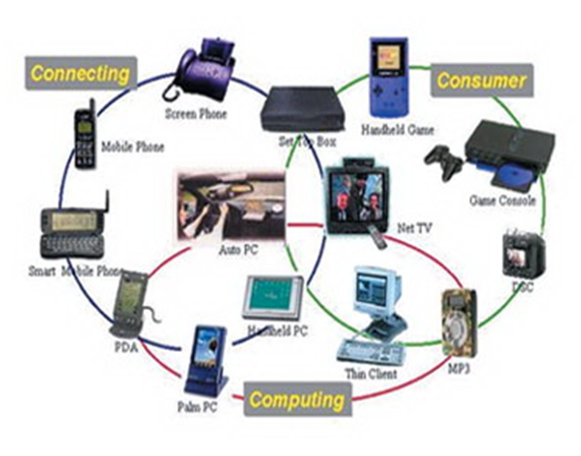
Fig 2.2: Network communication embedded systems
2.3.5 Different types of processing units:
The central processing unit (c.p.u) can be any one of the following microprocessor, microcontroller, digital signal processing.
- Among these Microcontroller is of low cost processor and one of the main advantage of microcontrollers is, the components such as memory, serial communication interfaces, analog to digital converters etc.., all these are built on a single chip. The numbers of external components that are connected to it are very less according to the application.
- Microprocessors are more powerful than microcontrollers. They are used in major applications with a number of tasking requirements. But the microprocessor requires many external components like memory, serial communication, hard disk, input output ports etc.., so the power consumption is also very high when compared to microcontrollers.
- Digital signal processing is used mainly for the applications that particularly involved with processing of signals
2.4 APPLICATIONS OF EMBEDDED SYSTEMS:
2.4.1 Consumer applications:
At home we use a number of embedded systems which include microwave oven, remote control, vcd players, dvd players, camera etc….
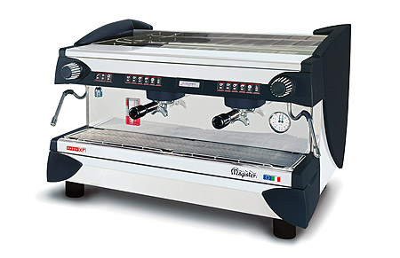
Fig 2.3: Automatic coffee makes equipment
2.4.2 Office automation:
We use systems like fax machine, modem, printer etc…
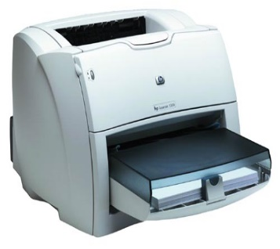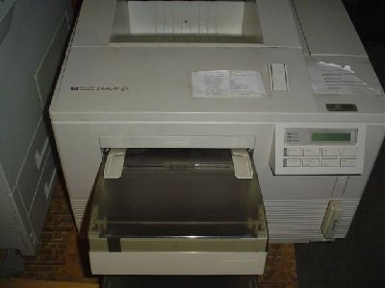
Fig 2.4: Fax machine Fig 2.5: Printing machine
2.4.3. Industrial automation:
Today a lot of industries are using embedded systems for process control. In industries we design the embedded systems to perform a specific operation like monitoring temperature, pressure, humidity ,voltage, current etc.., and basing on these monitored levels we do control other devices, we can send information to a centralized monitoring station.
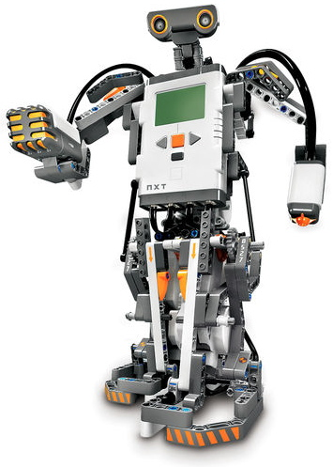
Fig 2.6: Vehicle
In critical industries where human presence is avoided there we can use vehicles which are programmed to do a specific operation.
2.4.4 Computer networking
Embedded systems are used as bridges routers etc..
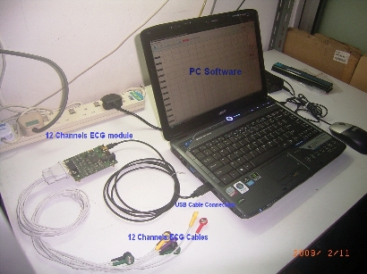
Fig 2.7: Computer networking
METHODOLOGY
3.1 EXISTING:
In existing system only CAN based communication using in automobiles for vehicle internal communication ,but there is no separate system to provide security to avoid accidents like rear end collision.
3.2 PROPOSED:
In proposed system we implemented sensors and RF based data transmission to the nearer vehicles while driving time. So that this system can detect the front vehicle sudden obstacle conditions using ultrasonic sensor and send signal to the can controller using microcontroller unit. Then microcontroller control the front vehicle ignition and following vehicle ignition automatically through RF wireless communication.
3.3 BLOCK DIAGRAM OF VEHICLE TO VEHICLE COMMUNICATION PROTOCOL:
3.3.1 Transmitter

3.3.2 Receiver

3.4 NODE MCU:
Node MCU is a low-cost open source IoT platform. It initially included firmware which runs on the ESP8266 Wi-Fi SoC from Espressif Systems, and hardware which was based on the ESP-12 module.[6][7] Later, support for the ESP32 32-bit MCU was added
3.4.1 Overview:
Node MCU is an open source firmware for which open source prototyping board designs are available. The name "Node MCU" combines "node" and "MCU" (micro-controller unit).[8]. The term "Node MCU" strictly speaking refers to the firmware rather than the associated development kits.[citation needed]
Both the firmware and prototyping board designs are open source.
The firmware uses the Lua scripting language. The firmware is based on the eLua project, and built on the Espressif Non-OS SDK for ESP8266. It uses many open source projects, such as lua-cjson[10] and SPIFFS.[11] Due to resource constraints, users need to select the modules relevant for their project and build a firmware tailored to their needs. Support for the 32-bit ESP32 has also been implemented.
The prototyping hardware typically used is a circuit board functioning as a dual in-line package (DIP) which integrates a USB controller with a smaller surface-mounted board containing the MCU and antenna. The choice of the DIP format allows for easy prototyping on breadboards. The design was initially was based on the ESP-12 module of the ESP8266, which is a Wi-Fi SoC integrated with a Tensilica Xtensa LX106 core, widely used in IoT applications
3.5 HISTORY:
Node MCU was created shortly after the ESP8266 came out. On December 30, 2013, Espressif Systems[6] began production of the ESP8266.[12] Node MCU started on 13 Oct 2014, when Hong committed the first file of nodemcu-firmware to GitHub.[13] Two months later, the project expanded to include an open-hardware platform when developer Huang R committed the gerber file of an ESP8266 board, named devkit v0.9.[14] Later that month, Tuan PM ported MQTT client library from Contiki to the ESP8266 SoC platform,[15] and committed to Node MCU project, then NodeMCU was able to support the MQTT IoT protocol, using Lua to access the MQTT broker. Another important update was made on 30 Jan 2015, when Devsaurus ported the u8glib[16] to the NodeMCU project,[17] enabling NodeMCU to easily drive LCD, Screen, OLED, even VGA displays. In the summer of 2015 the original creators abandoned the firmware project and a group of independent contributors took over. By the summer of 2016 the NodeMCU included more than 40 different modules.
3.6 INTRODUCTION TO NODE MCU:
NodeMCU is an open source LUA based firmware developed for ESP8266 wifi chip. By exploring functionality with ESP8266 chip, NodeMCU firmware comes with ESP8266 Development board/kit i.e. NodeMCU Development board. Since NodeMCU is open source platform, their hardware design is open for edit/modify/build. NodeMCU Dev Kit/board consist of ESP8266 wifi enabled chip. The ESP8266 is a low-cost Wi-Fi chip developed by Espressif Systems with TCP/IP protocol. For more information about ESP8266, you can refer ESP8266 WiFi Module. There is Version2 (V2) available for NodeMCU Dev Kit i.e. Node MCU Development Board v1.0 (Version2), which usually comes in black colored PCB.
NodeMCU Development Kit/Board consist of ESP8266 WIFI chip. ESP8266 chip has GPIO pins, serial communication protocol, etc. features on it.
ESP8266 is a low-cost Wi-Fi chip developed by Espressif Systems with TCP/IP protocol. For more information about ESP8266, you can refer ESP8266 WiFi Module.
The features of ESP8266 are extracted on NodeMCU Development board. NodeMCU (LUA based firmware) with Development board/kit that consist of ESP8266 (wifi enabled chip) chip combines NodeMCU Development board which make it stand-alone device in IoT applications.
Let’s see 1st version of NodeMCU Dev Kit and its pinout as shown in below images.

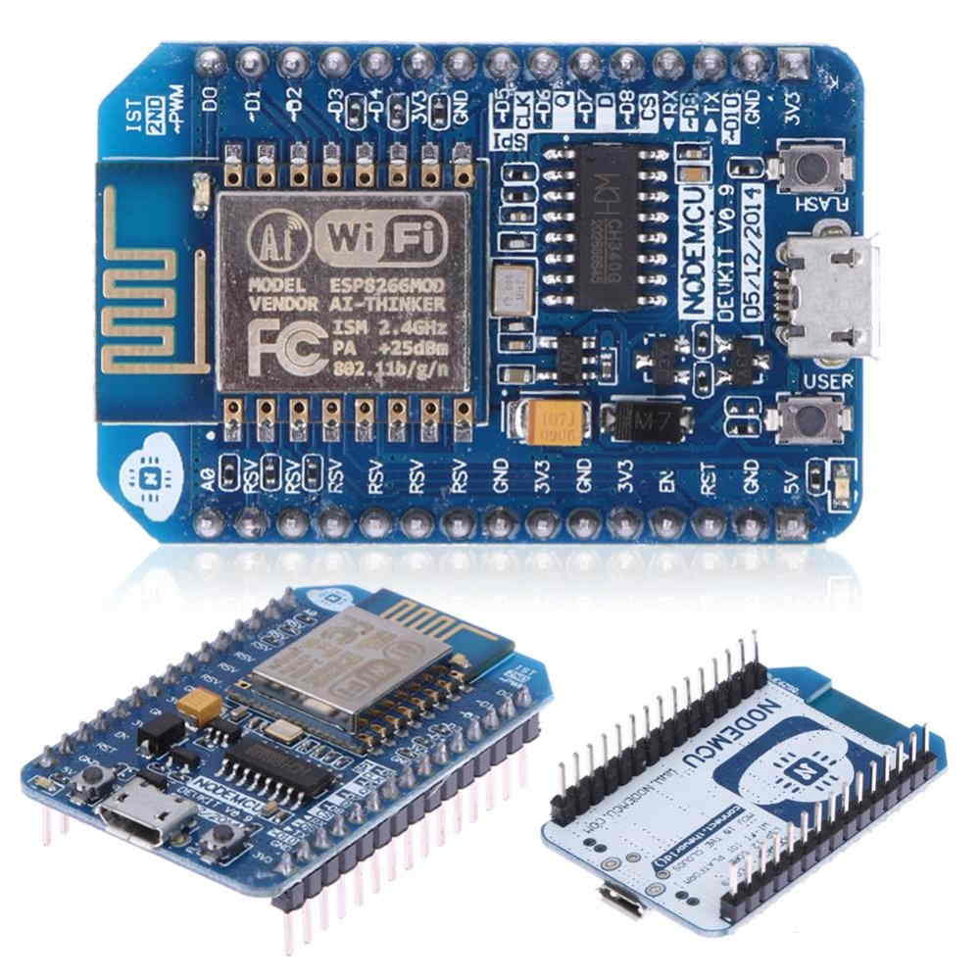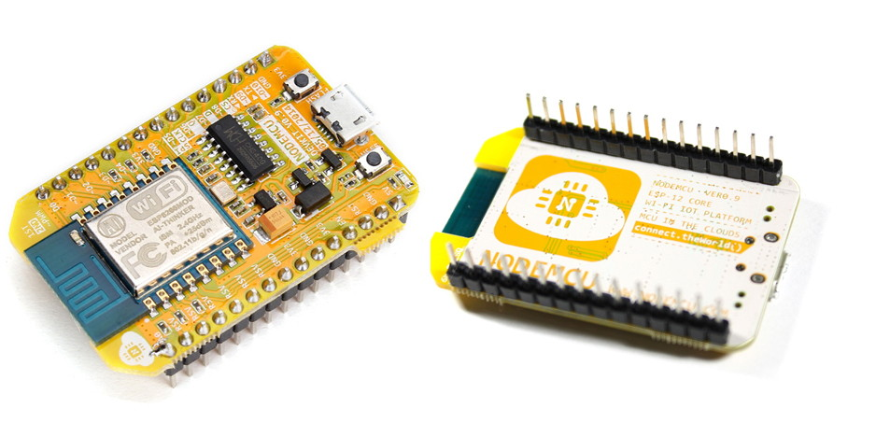

Fig 3.1 NodeMCU Development Board v0.9 (Version1)
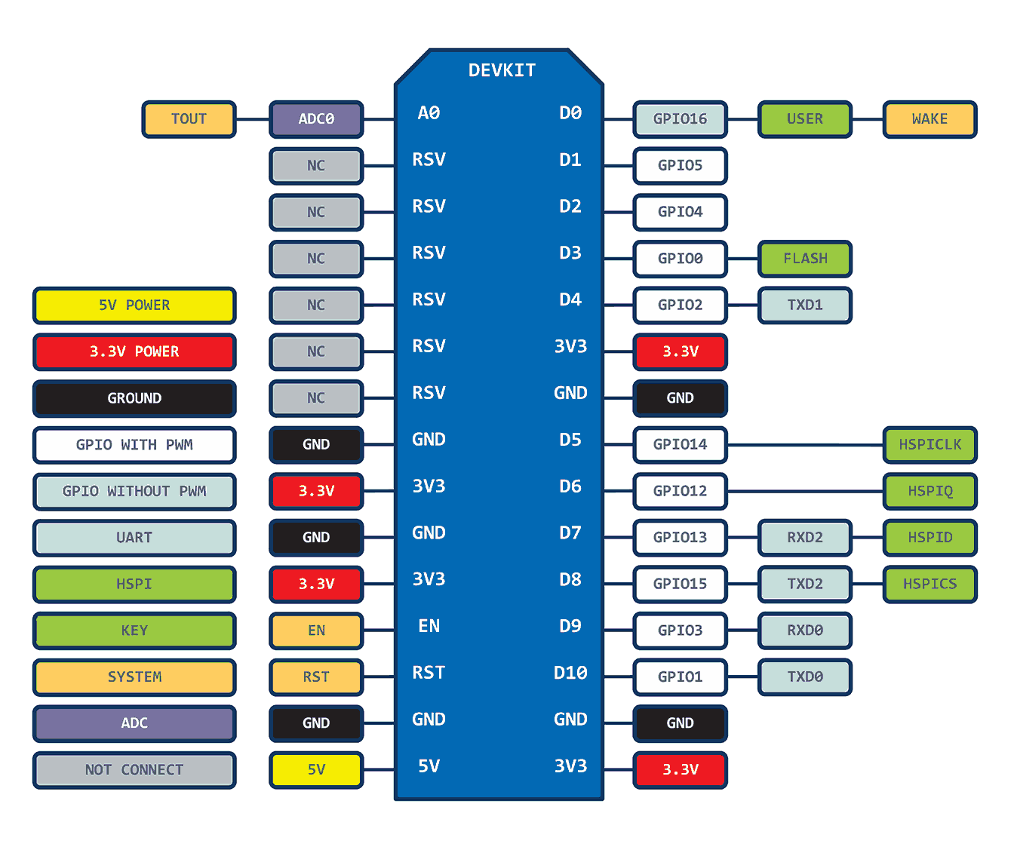
Fig 3.2 Node MCU Dev Kit v0.9(V1) Pinouts
2nd version of Node MCU Dev Kit and its Pinout as shown in below images.
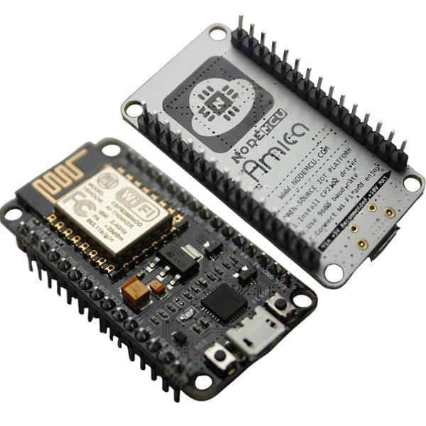
Fig 3.3 Amica Node MCU Dev Kit v1.0(Version2)
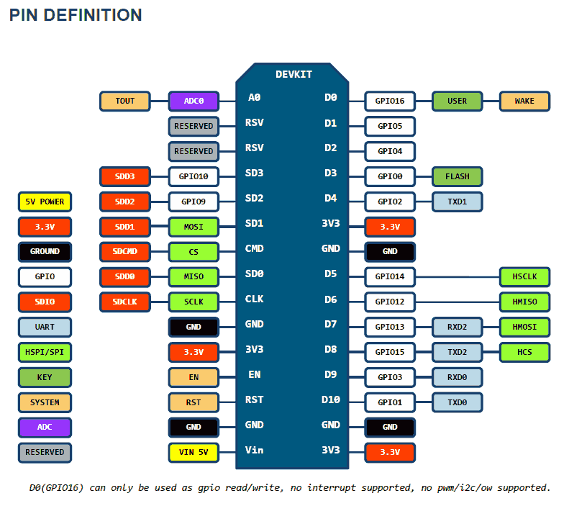
3.6.1 Node MCU Dev Kit v1.0(V2) Pinouts

Node MCU Dev Kit v1.0 pin descriptions
3.6.2 GPIO (General Purpose Input Output) Pins:
Node MCU has general purpose input output pins on its board as shown in above pinout diagram. We can make it digital high/low and control things like LED or switch on it. Also, we can generate PWM signal on these GPIO pins.
For more information about Node MCU GPIO
For more information about Node MCU PWM
3.6.3 ADC (Analog to Digital Converter) channel (A0):
Node MCU has one ADC channel/pin on its board.
For more information about Node MCU ADC
3.6.4 SPI (Serial Peripheral Interface) Pins:
Node MCU based ESP8266 has Hardware SPI (HSPI) with four pins available for SPI communication. It also has SPI pins for Quad-SPI communication. With this SPI interface, we can connect any SPI enabled device with Node MCU and make communication possible with it.
For more information about Node MCU SPI
3.6.5 I2C (Inter-Integrated Circuit) Pins:
Node MCU has I2C functionality support on ESP8266 GPIO pins. Due to internal functionality on ESP-12E we cannot use all its GPIOs for I2C functionality. So, do tests before using any GPIO for I2C applications.
For more information about Node MCU I2C
3.6.6 UART (Universal Asynchronous Receiver Transmitter) Pins:
Node MCU based ESP8266 has two UART interfaces, UART0 and UART1. Since UART0 (RXD0 & TXD0) is used to upload firmware/codes to board, we can’t use them in applications while uploading firmware/codes
3.7 IR SENSOR
An infrared sensor is an electronic device, that emits in order to sense some aspects of the surroundings. An IR sensor can measure the heat of an object as well as detects the motion. These types of sensors measure only infrared radiation, rather than emitting it that is called a passive IR sensor. Usually, in the infrared spectrum, all the objects radiate some form of thermal radiation. These types of radiations are invisible to our eyes, that can be detected by an infrared sensor. The emitter is simply an IR LED (Light Emitting Diode) and the detector is simply an IR photodiode that is sensitive to IR light of the same wavelength as that emitted by the IR LED. When IR light falls on the photodiode, the resistances and the output voltages will change in proportion to the magnitude of the IR light received.

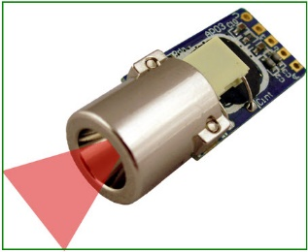
Fig 3.4 IR sensor
IR Sensor

IR Sensor Circuit Diagram and Working Principle
An infrared sensor circuit is one of the basic and popular sensor module in an electronic device. This sensor is analogous to human’s visionary senses, which can be used to detect obstacles and it is one of the common applications in real-time. This circuit comprises of the following components
- LM358 IC 2 IR transmitter and receiver pair
- Resistors of the range of kilo-ohms.
- Variable resistors.
- LED (Light Emitting Diode).
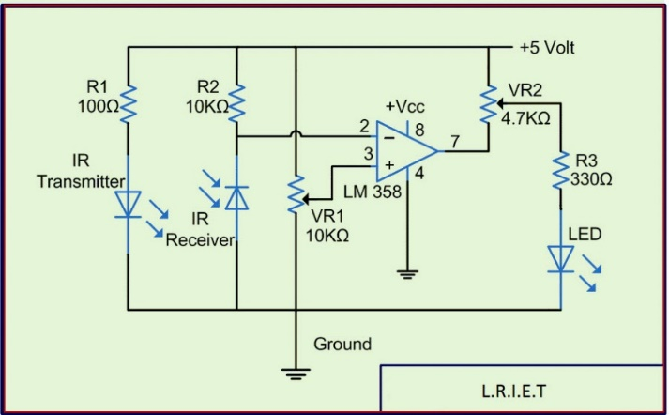
Fig 3.5 IR Sensor Circuit
In this project, the transmitter section includes an IR sensor, which transmits continuous IR rays to be received by an IR receiver module. An IR output terminal of the receiver varies depending upon its receiving of IR rays. Since this variation cannot be analyzed as such, therefore this output can be fed to a comparator circuit. Here an operational amplifier (op-amp) of LM 339 is used as comparator circuit.
When the IR receiver does not receive a signal, the potential at the inverting input goes higher than that non-inverting input of the comparator IC (LM339). Thus the output of the comparator goes low, but the LED does not glow. When the IR receiver module receives signal to the potential at the inverting input goes low. Thus the output of the comparator (LM 339) goes high and the LED starts glowing. Resistor R1 (100 ), R2 (10k ) and R3 (330) are used to ensure that minimum 10 mA current passes through the IR LED Devices like Photodiode and normal LEDs respectively. Resistor VR2 (preset=5k ) is used to adjust the output terminals. Resistor VR1 (preset=10k ) is used to set the sensitivity of the circuit Diagram. Read more about IR sensors.

3.7.1 DIFFERENT TYPES OF IR SENSORS
IR sensors are classified into different types depending on the applications. Some of the typical applications of different types of sensors are
The speed sensor is used for synchronizing the speed of multiple motors. The temperature sensor is used for industrial temperature control. PIR sensor is used for automatic door opening system and Ultrasonic sensor are used for distance measurement.

3.7.2 IR SENSOR APPLICATIONS
IR sensors are used in various Sensor based projects and also in various electronic devices which measures the temperature that are discussed in the below.

Radiation Thermometers: IR sensors are used in radiation thermometers to measure the temperature depend upon the temperature and the material of the object and these thermometers have some of the following features
- Measurement without direct contact with the object
- Faster response
- Easy pattern measurements

3.7.2.1 Flame Monitors
These types of devices are used for detecting the light emitted from the flames and to monitor how the flames are burning. The Light emitted from flames extend from UV to IR region types. PbS, PbSe, Two-color detector, pyro electric detector are some of the commonly employed detector used in flame monitors.

3.7.2.2 Moisture Analyzers
Moisture analyzers use wavelengths which are absorbed by the moisture in the IR region. Objects are irradiated with light having these wavelengths(1.1 µm, 1.4 µm, 1.9 µm, and 2.7µm) and also with reference wavelengths. The Lights reflected from the objects depend upon the moisture content and is detected by analyzer to measure moisture (ratio of reflected light at these wavelengths to the reflected light at reference wavelength). In GaAs PIN photodiodes, Pbs photoconductive detectors are employed in moisture analyzer circuits.

3.7.2.3 Gas Analyzers
IR sensors are used in gas analyzers which use absorption characteristics of gases in the IR region. Two types of methods are used to measure the density of gas such as dispersive and non-dispersive.
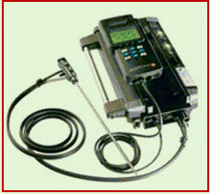
Fig 3.6 Gas Analizer
Dispersive: An Emitted light is spectroscopically divided and their absorption characteristics are used to analyze the gas ingredients and the sample quantity.
Non dispersive: It is most commonly used method and it uses absorption characteristics without dividing the emitted light. Non dispersive types use discrete optical band pass filters, similar to sunglasses that are used for eye protection to filter out unwanted UV radiation.
This type of configuration is commonly referred to as non-dispersive infrared (NDIR) technology. This type of analyzer is used for carbonated drinks, whereas non dispersive analyzer is used in most of the commercial IR instruments, for an automobile exhaust gas fuel leakages.

3.7.2.4 IR Imaging Devices
IR image device is one of the major applications of IR waves, primarily by virtue of its property that is not visible. It is used for thermal imagers, night vision devices, etc.
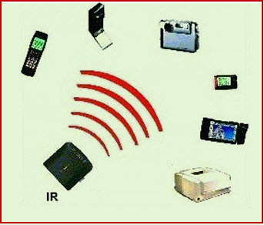
Fig 3.7 IR Imaging Devices
For examples Water, rocks, soil, vegetation, an atmosphere, and human tissue all features emit IR radiation. The Thermal infrared detectors measure these radiations in IR range and map the spatial temperature distributions of the object/area on an image. Thermal imagers usually composed of a Sb (indium antimonite), Gd Hg (mercury-doped germanium), Hg Cd Te (mercury-cadmium-telluride) sensors. An electronic detector is cooled to low temperatures using liquid helium or liquid nitrogen’s. Then the Cooling the detectors ensures that the radiant energy (photons) recorded by the detectors comes from the terrain and not from the ambient temperature of objects within the scanner itself an IR imaging electronic devices.
3.7.2.5 Gas Sensor MQ3
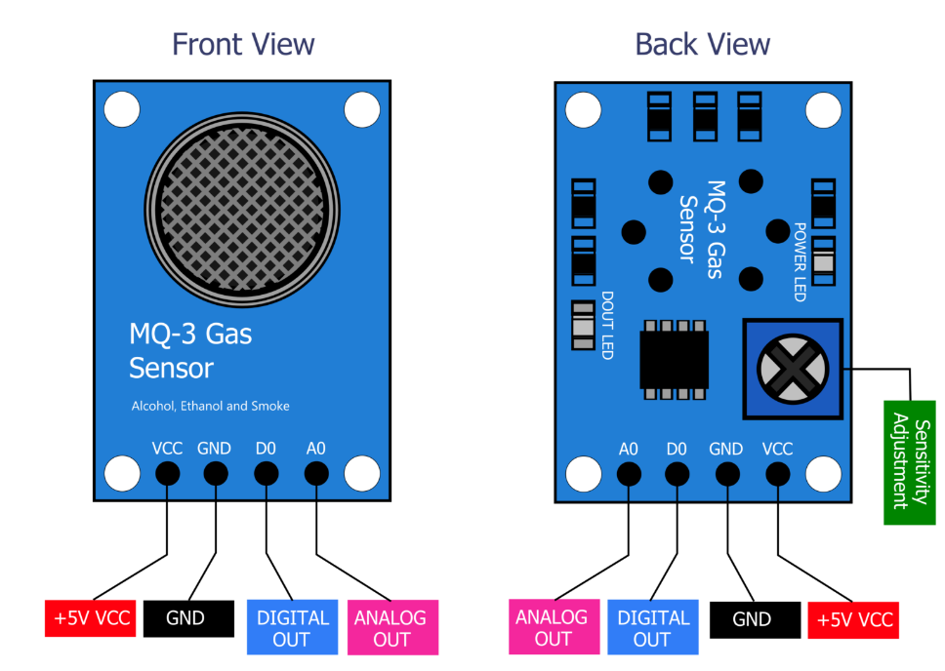
Fig 3.8 gas sensor
The MQ3 gas sensor is alcohol sensor which is used to detect the alcohol concentration on your breath. This sensor provides an analog resistive output based on alcohol concentration. When the alcohol gas exist, the sensor’s conductivity gets higher along with the gas concentration rising. It is suitable for various applications of detecting alcohol at different concentration. It is widely used in domestic alcohol gas alarm, industrial alcohol gas alarm and portable alcohol detector.

HARDWARE COMPONENTS
4.1 SPECIFICATIONS
- Supply Voltage: 5V
- Detecting Concentration:0.05-10mg/L Alcohol
- Analog and Digital Output
- Digital Out is High or Low based on a adjustable preset threshold.

4.2 HARDWARE CONNECTIONS
The connections are made as follows:
- Vcc to 5V
- GND to GND
4.3 TEMPERATURE SENSOR (LM35)
The LM35 sensor series are precision integrated-circuit temperature sensors, whose output voltage is linearly proportional to the Celsius (Centigrade) temperature.
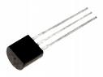
Fig 4.1 Temperature sensor
4.3.1 LM35 Sensor Specification
The LM35 series are precision integrated-circuit LM35 temperature sensors, whose output voltage is linearly proportional to the Celsius (Centigrade) temperature. The LM35 sensor thus has an advantage over linear temperature sensors calibrated in ° Kelvin, as the user is not required to subtract a large constant voltage from its output to obtain convenient Centigrade scaling. The LM35 sensor does not require any external calibration or trimming to provide typical accuracies of ±¼°C at room temperature and ±¾°C over a full -55 to +150°C temperature range. Low cost is assured by trimming and calibration at the wafer level. The LM35's low output impedance, linear output, and precise inherent calibration make interfacing to readout or control circuitry especially easy. It can be used with single power supplies, or with plus and minus supplies. As it draws only 60 µA from its supply, it has very low self-heating, less than 0.1°C in still air. The LM35 is rated to operate over a -55° to +150°C temperature range, while the LM35C sensor is rated for a -40° to +110°C range (-10° with improved accuracy). The LM35 series is available packaged in hermetic TO-46 transistor packages, while the LM35C, LM35CA, and LM35D are also available in the plastic TO-92 transistor package. The LM35D sensor is also available in an 8-lead surface mount small outline package and a plastic TO-220 package.
4.3.2 LM35 Sensor Circuit Schematic
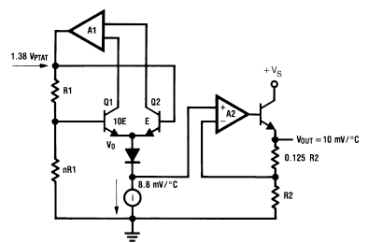
4.3.3 LM35 Sensor Pinouts and Packaging
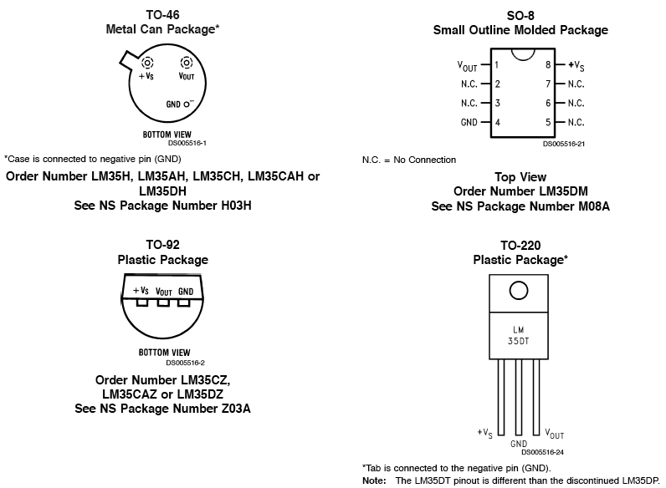

4.3.4 LM35 Sensor Sources
There are several manufacturers of this popular part and each has LM35 sensor specs, datasheets and other free LM35 downloads. This amplifier is available from the following manufacturers.
National Semiconductor
On Semiconductor
Texas Instruments
Fairchild Semiconductor
STMicroelectronics
Jameco Electronics
Analog Devices

4.3.5 LM35 Sensor Background and Applications
Most commonly-used electrical temperature sensors are difficult to apply. For example, thermocouples have low output levels and require cold junction compensation. Thermistors are nonlinear. In addition, the outputs of these sensors are not linearly proportional to any temperature scale. Early monolithic sensors, such as the LM3911, LM134 and LM135, overcame many of these difficulties, but their outputs are related to the Kelvin temperature scale rather than the more popular Celsius and Fahrenheit scales. Fortunately, in 1983 two I.C.’s, the LM34 Precision Fahrenheit Temperature Sensor and the LM35 Precision Celsius Temperature Sensor, were introduced. This application note will discuss the LM34, but with the proper scaling factors can easily be adapted to the LM35. The LM35/LM34 has an output of 10 mV/°F with a typical nonlinearity of only ±0.35°F over a −50 to +300°F temperature range, and is accurate to within ±0.4°F typically at room temperature (77°F). The LM34’s low output impedance and linear output characteristic make interfacing with readout or control circuitry easy. An inherent strength of the LM34 sensor over other currently available temperature sensors is that it is not as susceptible to large errors in its output from low level leakage currents. For instance, many monolithic temperature sensors have an output of only 1 μA/°K. This leads to a 1°K error for only 1 μ-Ampere of leakage current. On the other hand, the LM34 sensor may be operated as a current mode device providing 20 μA/°F of output current. The same 1 μA of leakage current will cause an error in the LM34’s output of only 0.05°F (or 0.03°K after scaling). Low cost and high accuracy are maintained by performing trimming and calibration procedures at the wafer level. The device may be operated with either single or dual supplies. With less than 70 μA of current drain, the LM34 sensor has very little self-heating (less than 0.2°F in still air), and comes in a TO-46 metal can package, a SO-8 small outline package and a TO-92 plastic package.
The LM35/LM34 is a versatile device which may be used for a wide variety of applications, including oven controllers and remote temperature sensing. The device is easy to use (there are only three terminals) and will be within 0.02°F of a surface to which it is either glued or cemented. The TO-46 package allows the user to solder the sensor to a metal surface, but in doing so, the GND pin will be at the same potential as that metal. For applications where a steady reading is desired despite small changes in temperature, the user can solder the TO-46 package to a thermal mass. Conversely, the thermal time constant may be decreased to speed up response time by soldering the sensor to a small heat fin.

4.4 CONTROLLER AREA NETWORK

4.4.1 CAN (Controller Area Network):
Controller Area Network (CAN) is a serial network that was originally designed for the automotive industry, but has also become a popular bus in industrial automation as well as other applications. The CAN bus is primarily used in embedded systems, and as its name implies, is the network established among microcontrollers. It is a two-wire, half duplex, high-speed network system and is well suited for high speed applications using short messages. Its robustness, reliability and the large following from the semiconductor industry are some of the benefits with CAN protocol can theoretically link up to 2032 devices (assuming one node with one identifier) on a single network. However, due to the practical limitation of the hardware (transceivers), it can only link up to110 nodes on a single network.
It offers high-speed communication rate up to 1 Mbits/sec thus allows real-time control. In addition, the error confinement and the error detection feature make it more reliable in noise critical environment.

4.4.2 History of CAN:
CAN was first developed by Robert Bosch GmbH, in 1986 when they were requested to develop a communication system between three ECUs (electronic control units) in vehicles by Mercedes. They found that an UART is no longer suitable in this situation because it is used in point-to-point communication. The need for a multi-master communication system became imperative. The first CAN silicon was then fabricated in 1987 by Intel.

4.4.3. CAN standards:
The original specification is the Bosch specification. Version 2.0 of this specification is divided into two parts:
Standard CAN (Version 2.0A). Uses 11 bit identifiers.
Extended CAN (Version 2.0B). Uses 29 bit identifiers.
The two parts define different formats of the message frame, with the main difference being the identifier length. There are two ISO standards for the difference is in the physical layer, where ISO 11898 handles high speed applications up to 1Mbit/second. ISO 11519 has an upper limit of 125kbit/second.

4.4.4 Working of CAN:
4.4.4.1. Introduction:
As stated earlier, CAN is a multi master network. It uses CSMA/CD+AMP (Carrier Sense Multiple Access/Collision Detection with Arbitration on Message Priority). Before sending a message the CAN node checks if the bus is busy. It also uses collision detection. In these ways it is similar to Ethernet. However, when an Ethernet network detects collision both sending nodes stop transmitting. They then wait a random time before trying to send again. CAN solve this problem with the very clever principle of arbitration.
4.4.4.2. Principle:
Data messages transmitted from any node on a CAN bus do not contain addresses of either the transmitting node, or of any intended receiving node.
Instead, the content of the message is labeled by an identifier that is unique throughout the network. All other nodes on the network receive the message and each performs an acceptance test on the identifier to determine if the message, and thus its content, is relevant to that particular node. If the message is relevant, it will be processed; otherwise it is ignored.
4.4.4.3 Identifiers:
The unique identifier also determines the priority of the message. The lower the numerical value of the identifier, the higher the priority. This allows arbitration if two (or more) nodes compete for access to the bus at the same time. The higher priority message is guaranteed to gain bus access as if it were the only message being transmitted.
Lower priority messages are automatically re-transmitted in the next bus cycle, or in a subsequent bus cycle if there are still other, higher priority messages waiting to be sent.
Each CAN message has an identifier which is 11 bits (CAN specification part A) or 29 bits (part B). This identifier is the Principle part of the CAN arbitration field, which is located in the beginning of each, CAN message. The identifier identifies the type of message, but is also the message priority. The bits in a CAN message can be sent as either high or low. The low bits are always dominant, which means that if one node tries to send a low and another node tries to send a high, the result on the buses will be a low. A transmitting node always listens on the bus while transmitting. A node that sends a high in the arbitration field and detects a low knows that it has lost arbitration. It stops transmitting, letting the other node, with a higher priority message, continue uninterrupted. Two nodes on the network are not allowed to send messages with the same id. If two nodes try to send a message with the same id at the same time arbitration will not work. Instead, one of the SS transmitting nodes will detect that his message is distorted outside of the arbitration field. The nodes will then use the error handling of CAN, which in this case ultimately will lead to one of the transmitting node being switched off (bus-off mode).

4.5. MESSAGE FORMATS:
4.5.1. Format of a CAN message:
In a CAN system, data is transmitted and received using Message Frames. Message Frames carry data from a transmitting node to one, or more, receiving nodes.
The CAN protocol supports two Message Frame formats. The two formats are:
- Standard CAN (Version 2.0A) - Extended CAN (Version 2.0B)
Most 2.0A controllers transmit and receive only Standard format messages, although some (known as 2.0B passive) will receive extended format messages but then ignore them. 2.0B controllers can send and receive messages in both formats.
4.5.2. CAN 2.0A Format:
A Standard CAN (Version 2.0A) Message Frame consists of seven different bit fields:
- A Start of Frame (SOF) field. This is a dominant (logic 0) bit that indicates the beginning of a message frame.
- An Arbitration field, containing an 11 bit message identifier and the Remote Transmission Request (RTR) bit. A dominant (logic 0), RTR bit indicates that the message is a Data Frame. A recessive (logic 1) value indicates that the message is a Remote Transmission Request (otherwise known as Remote Frame.) A Remote Frame is a request by one node for data from some other node on the bus. Remote Frames do not contain a Data Field.
- A Control Field containing six bits:
* two dominant bits (r0 and r1) that are reserved for future use, and
* a four bit Data Length Code (DLC). The DLC indicates the number of bytes in the Data Field that follows
- A Data Field, containing from zero to eight bytes.
- The CRC field, containing a fifteen bit cyclic redundancy checks code and a recessive delimiter bit
- The Acknowledge field, consisting of two bits. The first is the Slot bit which is transmitted as a recessive bit, but is subsequently over written by dominant bits transmitted from all other nodes that successfully receive the message. The second bit is a recessive delimiter bit
- The End of Frame field, consisting of seven recessive bits.
Following the end of a frame is the Intermission field consisting of three recessive bits. After the three bit Intermission period the bus is recognized to be free. Bus Idle time may be of any arbitrary length including zero.
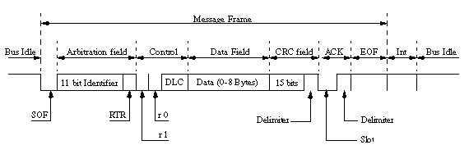
Fig 4.2 CAN format

4.5.3. Error detection and fault confinement:
The error detection, signaling and fault confinement defined in the CAN standard makes the CAN bus very reliable. The built in error detection of the controllers together with the error signaling make sure that the information is correct and consistent. Faulty nodes will go to modes where they do not disturb the traffic on the bus.
The CAN error process
- The error is detected by the CAN controller (a transmitter or a receiver).
- An error frame is immediately transmitted.
- The message is cancelled at all nodes (exceptions exist - CAN controller error modes).
- The status of the CAN controllers are updated (CAN controller error modes).
The message is re-transmitted. If several controllers have messages to send, normal arbitration is used.
4.5.4. Error detection:
Error detection is handled automatically by the CAN controller. The detected errors are:
- Bit errors:
  - Bit stuffing error - normally a transmitting node inserts a high after five consecutive low bits (and a low after five consecutive high). This is called bit stuffing. A receiving node that detects violation (more than five consecutive bits will see a bit stuffing violation.
  - Bit error: A transmitting node always reads back the message as it is sending. If it detects a different bit value on the bus than it sent, and the bit is not part of the arbitration field or in the acknowledgement field, and error is detected.
- Message errors:
Checksum error - each receiving node checks CAN messages for checksum errors.
- Frame error - There are certain predefined bit values that must be transmitted at certain points within any CAN Message Frame. If a receiver detects an invalid bit in one of these positions a Form Error (sometimes also known as a Format Error) will be flagged.
- Acknowledgement Error - If a transmitter determines that a message has not been acknowledged then an ACK Error is flagged.
4.5.5. Error Signaling:
When an error is detected by a node it sends an error flag on the bus. This prevents any other node from accepting the message and ensures consistency of data throughout the network. The active error flag consists of six low bits, and is used if the node transmitting the error frame is in active error state. As low is dominant all other nodes will detect bit stuffing violation and send their own error flags. After this, nodes that want to transmit (including the one sending the interrupted message) will start to do so. As usual, the node whose message has the highest priority will win arbitration and send its message.
If the CAN controller is in error passive mode the error frame will consist of six passive (high) bits. Since the error flag only consists of passive bits, the bus is not affected. If no other node detected an error, the message will be sent uninterrupted. This ensures that a node having problems with receiving cannot block the bus.
All of this advanced error handling is done automatically by the CAN controller, without any need for the host microcontroller to do anything. This is one of the big advantages of CAN.
4.5.6. Bit timing:
CAN has advanced features for coping with the time delays found in long bus lengths (in comparison to the bit rate) and coping with differences in clock Chrystal frequencies for nodes on the bus.
The choice of bit timing is very important since it decides the bit rate, the sample point and the ability to resynchronize.
4.5.7. Bit segments (as in Bosch standard)
Each bit is divided into four segments - the synchronization segment, the propagation segment and the phase segments one and two. Each segment consists of one or more time quanta.
A time quantum is a fixed amount of time which is derived from the CAN controller clock with a prescale factor.
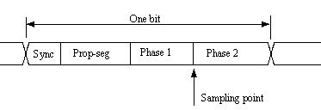
4.5.8. Synchronization segment (Synch_Seg)
The synchronization segment is used to synchronize the various nodes on the bus. When a bit is sent on the bus, the leading edge is expected to be within this segment.
This segment is always one time quantum long.
4.5.9. Propagation segment (Prop_Seg)
The Propagation Segment is needed to compensate for the delay in the bus lines.
The segment size is programmable between 1 and 8 time quanta.
4.5.10. Phase Segment 1 (Phase_Seg1), Phase Segment 2 (Phase_Seg2)
These segments can be used lengthened or shortened by resynchronization.
4.5.11. Bit segments (as in implementations like Intel 527 and C167CR)
In most implementations of CAN controllers the segments seem to be implemented in a different way than described in the standard. The synch segment looks as in the standard and consists of one time quantum. The big difference is that the propagation segment and the phase segment 1 in the standard have been combined into one segment, TSEG1. Phase segment 2 is left untouched, but is renamed to TSEG2.
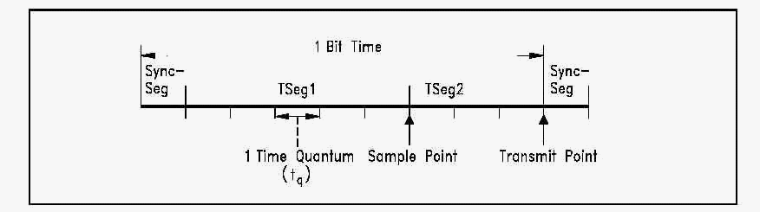
Normally there is only one sample point for each bit. In this case, the sample point is in the edge between TSEG1 and TSEG2. However, some CAN controllers can also sample each bit three times. In this case, the bit will be sampled three quanta in a row, with the last sample being taken in the edge between TSEG1 and TSEG2.
Three samples should only be used for relatively slow baud rates.
4.5.12. Calculation of baud rate and sample point Baud rate
The baud rate of the bus can be calculated from:
Baud rate = f crystal / (2*n*(BRP+1))
Where n is the number of time quanta for one bit and is defined as :
n = SYNCHSEG+TSEG1+TSEG2
BRP is the value of the Baud Rate Prescaler.
Warning: some CAN controllers (like Intel 526) has other way of calculating the number of time quanta’s in a bit! Consult your user’s manual.
Sample point
Quanta before sample = TSEG1 + 1
Quanta after sample = TSEG2
Often the sample point is given in percent of the bit time. This is:
(TSEG1+1)/(TSEG1+1+TSEG2)
Warning: some CAN controllers (like the C167CR) use other way of calculating Quanta after sample. Consult your manual!
4.5.13. Resynchronization
Resynchronization is done to compensate for bus delays and nodes that have different crystal frequencies. Synchronization is normally only done on the edge from recessive to dominant bus level.
4.5.14. Hard resynchronization
When the bus is idle and the controller detects a start bit, it resynchronizes itself so that the edge is inside the Synch segment. Hard resynchronization can only be made for the first bit in a frame.
4.5.15. Resynchronization within a frame
CAN controllers have the ability to synchronize on bit edges also within a frame. The (re)Synchronization Jump Width (SJW) decides the maximum number of time quanta that the controller can resynchronize every bit.
- Resynchronization of a receiver to a slower transmitter is handled as follows:
If a recessive-to-dominant edge appears inside TSEG1 and the edge is less than or equal to SJW quanta inside, TSEG1 is restarted. If the edge was more than SJW quanta inside, TSEG1 is lengthened with SJW quanta.
- Resynchronization of a receiver to a faster transmitter:
If a recessive-to-dominant edge appears inside TSEG2, TSEG2 is shortened by the number of quanta’s necessary to make the edge be outside TSEG2. However, TSEG2 can be shortened no more than SJW quanta.
4.5.16. CAN bus physical layer
The physical layer is not part of the Bosch CAN standard. However, in the ISO standards transceiver characteristics is included. CAN transmits signals on the CAN bus which consists of two wires, a CAN-High and CAN-Low. These 2 wires are operating in differential mode that is they are carrying inverted voltages (to decrease noise interference) the voltage levels, as well as other characteristics of the physical layer, depend on which standard is being used. Note that for the recessive state, nominal voltage for the two wires is the same. This decreases the power drawn from the nodes through the termination resistors. These resistors are 120ohm and are located on each end of the wires. Some people have played with using central termination resistors (that is, putting them in one place on the bus). This is not recommended; since that configuration will not prevent reflection problems. The voltage level on the CAN bus is recessive when the bus is idle.

4.6. BUS LENGTHS:
The maximum bus length for a CAN network depends on the bit rate used. It is required that the wave front of the bit signal has time to travel to the most remote node and back again before the bit is sampled. This means that if the bus length is near the maximum for the bit rate used, one should choose the sampling point with utmost care - one the other hand, one should always do that!

The maximum bus length for a CAN (Controller Area Network) network indeed hinges on the chosen bit rate. It's crucial to ensure that the wave front of the bit signal can traverse the entire length of the bus to the farthest node and back within the time allotted for sampling. Failure to meet this requirement can lead to signal distortion, errors, and ultimately, network failure. Hence, meticulous attention to selecting the sampling point is imperative, irrespective of the bus length relative to the maximum. When the bus length nears its maximum capacity for the given bit rate, the margin for error diminishes significantly. Every aspect of the network's configuration becomes critical, and even minor deviations can have pronounced effects on signal integrity. In such scenarios, precise timing of the sampling point becomes paramount. Engineers must carefully analyze factors such as cable quality, termination resistors, and signal propagation delays to optimize the network's performance.
Below is a table of different bus lengths and the corresponding maximum bit rates.
Table 4.3. BUS lengths
Bus length (meters) | Maximum bit rate (bit/s)
40 | 1 Mbit/s
100 | 500 kbit/s
200 | 250 kpit/s
500 | 125 kbit/s
6 km | 10 kbit/s

CAN CONTROLLER (MCP 2515)

5.1 DESCRIPTION:
MCP 2515 is a stand-alone-Controller Area Network(CAN) Controller that implements the CAN specification, version 2.0B. it is capable of transmitting and receiving both standard and extended data and remote frames. The MCP2515 has two acceptance masks and six acceptance filters that are used to filter out unwanted messages, thereby reducing the host MCUs overhead. The MCP2515 interfaces with microcontrollers (MCUs) via a industry standard Serial Peripheral Interface (SPI).

5.2 FEATURES:
- Receive buffers, masks and filters:
  - Two receive buffers with prioritized message storage
  - Six 29 bit filters.
  - Two 29 bit masks.
- Data byte filtering on the first two data bytes(applies to standard data frames)
- Three transmit buffers with prioritization and abort features.
- High-Speed SPI Interface(10MHz):
  - SPI modes 0,0 and 1,1
- One-shot mode ensures message transmission is attempted only one time
- Clock out pin with programmable prescaler:
  - Can be used as a clock source for other device(s)
- Start-of-Frame (SOF) signal is available for monitoring the SOF signal.
  - Can be used for time-slot-based protocols and/or bus diagnostics to detect early bus degradation.
- Interrupt output pin with selectable enables.
- Buffer Full output pins configurable as:
- Interrupt output for each receive buffer
- General Purpose output.
- Request-to-send (RTS) input pins individually configurable as
  - Control pins to request transmission for each transmit buffer
  - General purpose inputs.
- Low power CMOS technology:
  - Operates from 2.7v-5.5v

5.3 PIN DIAGRAM:

5.3.1. Pin Description:
Fig 5.1 Pin diagram of MCP 2515

DEVICE OVERVIEW:
The MCP2515 is a stand-alone CAN controller developed to simplify applications that require interfacing with a CAN bus. A simple block diagram of the MCP2515 is shown in Figure 5.1. The device consists of three main blocks:
- The CAN module, which includes the CAN protocol engine, masks, filters, transmit and receive buffers.
- The control logic and registers that are used to configure the device and its operation.
3.The SPI protocol block. An example system implementation using the device is shown above

CAN MODULE:
The CAN module handles all functions for receiving and transmitting messages on the CAN bus. Messages are transmitted by first loading the appropriate message buffer and control registers. Transmission is initiated by using control register bits via the SPI interface or by using the transmit enable pins. Status and errors can be checked by reading the appropriate registers. Any message detected on the CAN bus is checked for errors and then matched against the user defined filters to see if it should be moved into one of the two receive buffers.
5.5.1 Control Logic:
The control logic block controls the setup and operation of the MCP2515 by interfacing to the other blocks in order to pass information and control. Interrupt pins are provided to allow greater system flexibility. There is one multi-purpose interrupt pin (as well as specific interrupt pins) for each of the receive registers that can be used to indicate a valid message has been received and loaded into one of the receive buffers. Use of the specific interrupt pins is optional. The general purpose interrupt pin, as well as status registers (accessed via the SPI interface), can also be used to determine when a valid message has been received.
Additionally, there are three pins available to initiate immediate transmission of a message that has been loaded into one of the three transmit registers. Use of these pins is optional, as initiating message transmissions can also be accomplished by utilizing control registers, accessed via the SPI interface.

5.6 SPI PROTOCOL:
The MCU interfaces to the device via the SPI interface. Writing to, and reading from, all registers is accomplished using standard SPI read and write commands, in addition to specialized SPI commands.
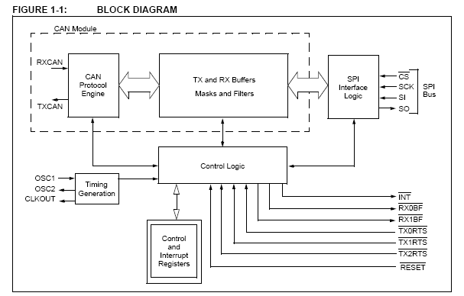

Fig 5.2 CAN Circuit

    - CAN Protocol Engine:
The CAN protocol engine combines several functional blocks, shown in Fig 5.3 and described below.
Fig 5.3 CAN Engine
    - Protocol Finite State machine
The heart of the engine is the Finite State Machine (FSM). The FSM is a sequencer that controls the sequential data stream between the TX/RX shift register, the CRC register and the bus line. The FSM also controls the Error Management Logic (EML) and the parallel data stream between the TX/RX shift registers and the buffers. The FSM ensures that the processes of reception, arbitration, transmission and error-signaling are performed according to the CAN protocol. The automatic retransmission of messages on the bus line is also handled by the FSM.
    - Cyclic Redundancy Check
The Cyclic Redundancy Check register generates the Cyclic Redundancy Check (CRC) code, which is transmitted after either the Control Field (for messages with 0 data bytes) or the Data Field and is used to check the CRC field of incoming messages.
    - Error Management Logic
The Error Management Logic (EML) is responsible for the fault confinement of the CAN device. Its two counters, the Receive Error Counter (REC) and the Transmit Error Counter (TEC), are incremented and decremented by commands from the bit stream processor. Based on the values of the error counters, the CAN controller is set into the states error-active, error-passive or bus-off.
    - Bit Timing Logic
The Bit Timing Logic (BTL) monitors the bus line input and handles the bus-related bit timing according to the CAN protocol. The BTL synchronizes on a recessive to- dominant bus transition at Start-of-Frame (hard synchronization) and on any further recessive-to-dominant bus line transition if the CAN controller itself does not transmit a dominant bit (resynchronization). The BTL also provides programmable time segments to compensate for the propagation delay time, phase shifts and to define the position of the sample point within the bit time. The programming of the BTL depends on the baud rate and external physical delay times.

MESSAGE TRANSMISSION
5.7.1 Transmit Buffers
The MCP2515 implements three transmit buffers. Each of these buffers occupies 14 bytes of SRAM and are mapped into the device memory map.
The first byte, TXBnCTRL, is a control register associated with the message buffer. The information in this register determines the conditions under which the message will be transmitted and indicates the status of the message transmission (Register 3-1through Register 3-2).

Five bytes are used to hold the standard and extended identifiers, as well as other message arbitration information (Register 3-3 through Register 3-7).

The last eight bytes are for the eight possible data bytes of the message to be transmitted (Register 3-8).
At a minimum, the TXBnSIDH, TXBnSIDL and TXBnDLC registers must be loaded. If data bytes are present in the message, the TXBnDm registers must also be loaded. If the message is to use extended identifiers, the TXBnEIDm registers must also be loaded and the TXBnSIDL.EXIDE bit set.
Prior to sending the message, the MCU must initialize the CANINTE.TXInE bit to enable or disable the generation of an interrupt when the message is sent.
Note: The TXBnCTRL.TXREQ bit must be clear (indicating the transmit buffer is not pending transmission) before writing to the transmit buffer.
5.7.2 Transmit Priority
Transmit priority is a prioritization within the MCP2515 of the pending transmittable messages. This is independent from, and not necessarily related to, any prioritization implicit in the message arbitration scheme built into the CAN protocol.
Prior to sending the SOF, the priority of all buffers that are queued for transmission is compared. The transmit buffer with the highest priority will be sent first. For example, if transmit buffer 0 has a higher priority setting than transmit buffer 1, buffer 0 will be sent first. If two buffers have the same priority setting, the buffer with the highest buffer number will be sent first. For example, if transmit buffer 1 has the same priority setting as transmit buffer 0, buffer 1 will be sent first. There are four levels of transmit priority. If TXBnCTRL.TXP<1:0> for a particular message buffer is set to 11, that buffer has the highest possible priority. If TXBnCTRL.TXP<1:0> for a particular message buffer is 00, that buffer has the lowest possible priority.
    - Initiating Transmission
In order to initiate message transmission, the TXBnCTRL.TXREQ bit must be set for each buffer to be transmitted. This can be accomplished by:
- Writing to the register via the SPI write command
- Sending the SPI RTS command
- Setting the TXnRTS pin low for the particular transmit buffer(s) that are to be transmitted
If transmission is initiated via the SPI interface, the TXREQ bit can be set at the same time as the TXP priority bits.When TXBnCTRL.TXREQ is set, the TXBnCTRL.ABTF, TXBnCTRL.MLOA and TXBnCTRL.TXERR bits will be cleared automatically.
Note: Setting the TXBnCTRL.TXREQ bit does not initiate a message transmission. It merely flags a message buffer as being ready for transmission. Transmission will start when the device detects that the bus is available.
Once the transmission has completed successfully, the TXBnCTRL.TXREQ bit will be cleared, the CANINTF.TXnIF bit will be set and an interrupt will be generated if the CANINTE.TXnIE bit is set.
If the message transmission fails, the TXBnCTRL.TXREQ will remain set. This indicates that the message is still pending for transmission and one of the following condition flags will be set:
- If the message started to transmit but encountered an error condition, the TXBnCTRL.TXERR and the CANINTF.MERRF bits will be set and an interrupt will be generated on the INT pin if the CANINTE.MERRE bit is set.
- If the message is lost, arbitration at the TXBnCTRL.MLOA bit will be set.
    - One-Shot Mode:
One-shot mode ensures that a message will only attempt to transmit one time. Normally, if a CAN message loses arbitration, or is destroyed by an error frame, the message is retransmitted. With One-shot mode enabled, a message will only attempt to transmit one time, regardless of arbitration loss or error frame. One-shot mode is required to maintain time slots in deterministic systems, such as TTCAN.
    - TXnRTS PINS
The TXnRTS pins are input pins that can be configured as:
- Request-to-send inputs, which provides an alternative means of initiating the transmission of a message from any of the transmit buffers.
- Standard digital inputs.
Configuration and control of these pins is accomplished using the TXRTSCTRL register (Register 3-3). The TXRTSCTRL register can only be modified when the MCP2515 is in Configuration mode. If configured to operate as a request-to-send pin, the pin is mapped into the respective TXBnCTRL.TXREQ bit for the transmit buffer. The TXREQ bit is latched by the falling edge of the TXnRTS pin. The TXnRTS pins are designed to allow them to be tied directly to the RXnBF pins to automatically initiate a message transmission when the RXnBF pin goes low.
The TXnRTS pins have internal pull-up resistors of 100 kΩ (nominal).
    - Aborting Transmission
The MCU can request to abort a message in a specific message buffer by clearing the associated TXBnCTRL.TXREQ bit.In addition; all pending messages can be requested to be aborted by setting the CANCTRL.ABAT bit. This bit MUST be reset (typically after the TXREQ bits have been verified to be cleared) to continue transmitting messages. The CANCTRL.ABTF flag will only be set if the abort was requested via the CANCTRL.ABAT bit. Aborting a message by resetting the TXREQ bit does NOT cause the ABTF bit to be set.

MESSAGE RECEPTION
    - Receive Message Buffering
The MCP2515 includes two full receive buffers with multiple acceptance filters for each. There is also a separate Message Assembly Buffer (MAB) that acts as a third receive buffer (Figure 4-2).
Fig 5.4 receive buffer block diagram
    - Message Assembly Buffer
Of the three receive buffers; the MAB is always committed to receiving the next message from the bus. The MAB assembles all messages received. These messages will be transferred to the RXBn buffers (Register 4-4 to Register 4-9) only if the acceptance filter criteria is met.

    - RXB0 AND RXB1
The remaining two receive buffers, called RXB0 and RXB1, can receive a complete message from the protocol engine via the MAB. The MCU can access one buffer, while the other buffer is available for message reception, or for holding a previously received message.
Note: The entire contents of the MAB is moved into the receive buffer once a message is accepted. This means that, regardless of the type of identifier (standard or extended) and the number of data bytes received, the entire receive buffer is overwritten with the MAB contents. Therefore, the contents of all registers in the buffer must be assumed to have been modified when any message is received.
    - Receive Flags/Interrupts
When a message is moved into either of the receive buffers, the appropriate CANINTF.RXnIF bit is set. This bit must be cleared by the MCU in order to allow a new
Message to be received into the buffer. This bit provides a positive lockout to ensure that the MCU has finished with the message before the MCP2515 attempts to load a new message into the receive buffer.
If the CANINTE.RXnIE bit is set, an interrupt will be generated on the INT pin to indicate that a valid message has been received. In addition, the associated RXnBF pin will drive low if configured as a receive buffer full pin.
    - Receive Priority
RXB0, the higher priority buffer, has one mask and two message acceptance filters associated with it. The received message is applied to the mask and filters for RXB0 first. RXB1 is the lower priority buffer, with one mask and four acceptance filters associated with it.
In addition to the message being applied to the RB0 masks and filters first, the lower number of acceptance filters makes the match on RXB0 more restrictive and implies a higher priority for that buffer. When a message is received, bits <3:0> of the RXBnCTRL register will indicate the acceptance filter number that enabled reception and whether the received message is a remote transfer request.
    - Rollover:
Additionally, the RXB0CTRL register can be configured such that, if RXB0 contains a valid message and another valid message is received, an overflow error will not occur and the new message will be moved into RXB1, regardless of the acceptance criteria of RXB1.
    - RXM Bits:
The RXBnCTRL.RXM bits set special receive modes. Normally, these bits are cleared to 00 to enable reception of all valid messages as determined by the appropriate acceptance filters. In this case, the determination of whether or not to receive standard or Extended messages are determined by the RFXnSIDL.EXIDE bit in the acceptance filter register.
If the RXBnCTRL.RXM bits are set to 01 or 10, the receiver will only accept messages with standard or extended identifiers, respectively. If an acceptance filter has the RFXnSIDL.EXIDE bit set such that it does not correspond with the RXBnCTRL.RXM mode, that acceptance filter is rendered useless. These two modes of RXBnCTRL.RXM bits can be used in systems where it is known that only standard or extended messages will be on the bus.
If the RXBnCTRL.RXM bits are set to 11, the buffer will receive all messages, regardless of the values of the acceptance filters. Also, if a message has an error before the EOF, that portion of the message assembled in the MAB before the error frame will be loaded into the buffer. This mode has some value in debugging a CAN system and would not be used in an actual system environment.
    - Start-of-Frame Signal
If enabled, the Start-Of-Frame signal is generated on the SOF pin at the beginning of each CAN message detected on the RXCAN pin. The RXCAN pin monitors an idle bus for a recessive to- dominant edge. If the dominant condition remains until the sample point, the DSTEMP interprets this as a SOF and a SOF pulse is generated.
If the dominant condition does not remain until the sample point, the DSTEMP interprets this as a glitch on the bus and no SOF signal is generated. Figure 4-1 illustrates SOF signaling and glitch-filtering.
Fig 5.5 start-of-frame signaling
As with One-shot mode, one use for SOF signaling is for TTCAN-type systems. In addition, by monitoring both the RXCAN pin and the SOF pin, a MCU can detect early physical bus problems by detecting small glitches before they affect the CAN communications.
    - RX0BF and RX1BF Pins
In addition to the INT pin, which provides an interrupt signal to the MCU for many different conditions, the receive buffer full pins (RX0BF and RX1BF) can be used to indicate that a valid message has been loaded into RXB0 or RXB1, respectively. The pins have three different configurations (Register 4-1):
- Disabled.
- Buffer Full Interrupt.
- Digital Output.
    - Disabled:
The RXBnBF pins can be disabled to the high impedance state by clearing BFPCTRL.BnBFE.
    - Configured as Buffer Full:
The RXBnBF pins can be configured to act as either buffer full interrupt pins or as standard digital outputs. Configuration and status of these pins is available via the BFPCTRL register (Register 4-3). When set to operate in Interrupt mode (by setting BFPCTRL.BxBFE and BFPCTRL.BxBFM bits), these pins are active-low and are mapped to the CANINTF.RXnIF bit for each receive buffer. When this bit goes high for one of the receive buffers (indicating that a valid message has been loaded into the buffer), the corresponding RXBnBF pin will go low. When the CANINTF.RXnIF bit is cleared by the MCU, the corresponding interrupt pin will go to the logic-high state until the next message is loaded into the receive buffer.
    - Configured as Digital Output:
When used as digital outputs, the BFPCTRL.BxBFM bit must be cleared and BFPCTRL.BnBFE must be set for the associated buffer. In this mode, the state of the pin
Is controlled by the BFPCTRL.BnBFS bits. Writing a ‘1’ to the BnBFS bit will cause a high level to be driven on the associated buffer full pin, while a ‘0’ will cause the pin to drive low. When using the pins in this mode, the state of the pin should be modified only by using the Bit Modify SPI command to prevent glitches from occurring on either of the buffer full pins.
    - Message Acceptance Filters and Masks:
The message acceptance filters and masks are used to determine if a message in the message assembly buffer should be loaded into either of the receive buffers (Figure 4-5). Once a valid message has been received into the MAB, the identifier fields of the message are compared to the filter values. If there is a match, that message will be loaded into the appropriate receive buffer.
Fig 5.6 message acceptance mask and filter operation
    - Data Byte Filtering:
When receiving standard data frames (11-bit identifier), the DSTEMP automatically applies 16 bits of masks and filters normally associated with extended identifiers to the first 16 bits of the data field (data bytes 0 and 1). Figure 4-4 illustrates how masks and filters apply to extended and standard data frames.
Data byte filtering reduces the load on the MCU when implementing Higher Layer Protocols (HLPs) that filter on the first data byte (e.g., Device Net™).
Fig 5.7 masks and filters to can frames
    - Filter Matching:
The filter masks (see Register 4-14 through Register 4-17) are used to determine which bits in the identifier are examined with the filters.

MODES OF OPERATION:
The MCP2515 has five modes of operation. These modes are:
- Configuration mode.
- Normal mode.
- Loopback mode.
5.9.1 Configuration Mode:
The MCP2515 must be initialized before activation.
5.9.2 Loopback Mode:
Loop back mode will allow internal transmission of messages from the transmit buffers to the receive buffers without actually transmitting messages on the CAN bus. This mode can be used in system development and testing.
5.9.3 Normal Mode:
Normal mode is the standard operating mode of the MCP2515. In this mode, the device actively monitors all bus messages and generates acknowledge bits, error frames, etc. This is also the only mode in which the MCP2515 will transmit messages over the CAN bus.

SPI INTERFACE
    - Overview:
The MCP2515 is designed to interface directly with the Serial Peripheral Interface (SPI) port available on many microcontrollers and supports Mode 0,0 and Mode 1,1. Commands and data are sent to the device via the SI pin, with data being clocked in on the rising edge of SCK. Data is driven out by the MCP2515 (on the SO line) on the falling edge of SCK. The CS pin must be held low while any operation is performed.
Below table shows the instruction bytes for all operations.
    - Reset Instruction
The Reset instruction can be used to re-initialize the internal registers of the MCP2515 and set Configuration mode. This command provides the same functionality, via the SPI interface, as the RESET pin.
    - Read Instruction
The Read instruction is started by lowering the CS pin. The Read instruction is then sent to the MCP2515 followed by the 8-bit address (A7 through A0). Next, the data stored in the register at the selected address will be shifted out on the SO pin. The internal address pointer is automatically incremented to the next address once each byte of data is shifted out. Therefore, it is possible to read the next consecutive register address by continuing to provide clock pulses. Any number of consecutive register locations can be read sequentially using this method. The read operation is terminated by raising the CS pin (Figure 12-2).
Fig 5.8 read instruction
    - Read RX Buffer Instruction
The Read RX Buffer instruction (Figure 12-3) provides a means to quickly address a receive buffer for reading. This instruction reduces the SPI overhead by one byte, the address byte. The command byte actually has four possible values that determine the address pointer location. Once the command byte is sent, the controller clocks out the data at the address location the same as the Read instruction (i.e., sequential reads are
Possible). This instruction further reduces the SPI overhead by automatically clearing the associated receive flag (CANINTF.RXnIF) when CS is raised at the end of the command.
Fig 5.9 Read RX buffer instruction
    - Write Instruction
The Write instruction is started by lowering the CS pin. The Write instruction is then sent to the MCP2515 followed by the address and at least one byte of data. It is possible to write to sequential registers by continuing to clock in data bytes, as long as CS is held low. Data will actually be written to the register on the rising edge of the SCK line for the D0 bit. If the CS line is brought high before eight bits are loaded, the write will be aborted for that data byte and previous bytes in the command will have been written. Refer to the timing diagram in Figure 12-4 for a more detailed illustration of the byte write sequence.
    - Load TX Buffer Instruction
The Load TX Buffer instruction (Figure 12-5) eliminates the eight-bit address required by a normal write command. The eight-bit instruction sets the address pointer to one of six addresses to quickly write to a transmit buffer that points to the “ID” or “data” address of any of the three transmit buffers.
    - Request-To-Send (RTS) Instruction
The RTS command can be used to initiate message transmission for one or more of the transmit buffers. The MCP2515 is selected by lowering the CS pin. The RTS command byte is then sent. Shown in Figure 12-6, the last 3 bits of this command indicate which transmit buffer(s) are enabled to send.
This command will set the TxBnCTRL.TXREQ bit for the respective buffer(s). Any or all of the last three bits can be set in a single command. If the RTS command is sent with nnn = 000, the command will be ignored.
    - Read Status Instruction
The Read Status instruction allows single instruction access to some of the often used status bits for message reception and transmission. The MCP2515 is selected by lowering the CS pin and the read status command byte is sent to the MCP2515.
Once the command byte is sent, the MCP2515 will return eight bits of data that contain the status. If additional clocks are sent after the first eight bits are transmitted, the MCP2515 will continue to output the status bits as long as the CS pin is held low and clocks are provided on SCK.

DESCRIPTION OF MCP 2551:
The MCP2551 is a high-speed CAN, fault-tolerant device that serves as the interface between a CAN protocol controller and the physical bus. The MCP2551 provides differential transmit and receive capability for the CAN protocol controller and is fully compatible with the ISO-11898 standard, including 24V requirements. It will operate at speeds of up to 1 Mb/s.
Typically, each node in a CAN system must have a device to convert the digital signals generated by a CAN controller to signals suitable for transmission overthe bus cabling (differential output). It also provides a buffer between the CAN controller and the high-voltage spikes that can be generated on the CAN bus by outside sources (EMI, ESD, electrical transients, etc.)
    - Features:
- Supports 1 Mb/s operation
- Implements ISO-11898 standard physical layer Requirements
- Suitable for 12V and 24V systems
- Externally-controlled slope for reduced RFI Emissions
- Detection of ground fault (permanent dominant) on TXD input
- Power-on reset and voltage brown-out protection
- An unpowered node or brown-out event will not disturb the CAN bus
- Low current standby operation
- Protection against damage due to short-circuit conditions (positive or negative battery voltage)
- Protection against high-voltage transients
- Automatic thermal shutdown protection
- Up to 112 nodes can be connected
- High noise immunity due to differential bus Implementation
- Temperature ranges:
  - Industrial (I): -40°C to +85°C
  - Extended (E): -40°C to +125°C

PIN CONFIGURATION
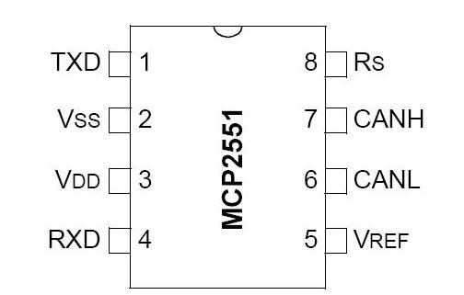
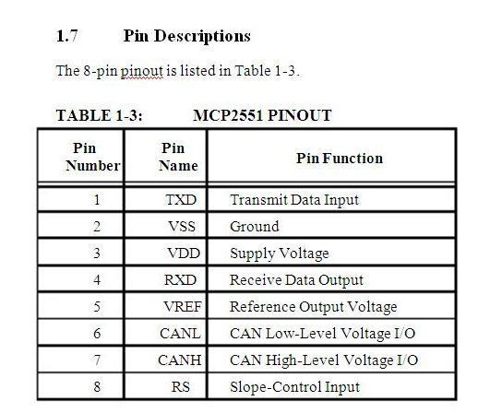
Fig 5.10. Pin diagram of 2551

DEVICE OVERVIEW:
The MCP2551 is a high-speed CAN, fault-tolerant device that serves as the interface between a CAN protocol controller and the physical bus. The MCP2551 provides differential transmit and receive capability for the CAN protocol controller and is fully compatible with the ISO-11898 standard, including 24V requirements. It will operate at speeds of up to 1 Mb/s.
Typically, each node in a CAN system must have a device to convert the digital signals generated by a CAN controller to signals suitable for transmission over the bus cabling (differential output). It also provides a buffer between the CAN controller and the high-voltage spikes that can be generated on the CAN bus by outside sources (EMI, ESD, electrical transients, etc.).
SOURCE CODE
6.1 OUTPUT:
6.1.1 Transmitter Code:
#include <ESP8266WiFi.h>
#include <espnow.h>
#include <Wire.h>
#include <LiquidCrystal_I2C.h>
LiquidCrystal_I2C lcd(0x27, 16, 2);
#define buzzer D5
// Structure to receive data
typedef struct struct_message {
float temperature;
float humidity;
int gasSensorValue;
int irSensorValue;
} struct_message;
// Data container
struct_message myData;
// Callback function that will be executed when data is received
void OnDataRecv(uint8_t * mac, uint8_t *incomingData, uint8_t len) {
memcpy(&myData, incomingData, sizeof(myData));
Serial.print("Bytes received: ");
Serial.println(len);
Serial.print("Temperature: ");
Serial.println(myData.temperature);
Serial.print("Humidity: ");
Serial.println(myData.humidity);
Serial.print("Gas Sensor Value: ");
Serial.println(myData.gasSensorValue);
Serial.print("IR Sensor Value: ");
Serial.println(myData.irSensorValue);
lcd.setCursor(0, 0);
lcd.print("T:");
lcd.print(myData.temperature);
lcd.setCursor(0, 1);
lcd.print("H:");
lcd.print(myData.humidity);
lcd.setCursor(8, 0);
lcd.print("G:");
lcd.print(myData.gasSensorValue);
lcd.setCursor(8, 1);
lcd.print("F:");
lcd.print("60%");
}
void setup() {
pinMode(buzzer,OUTPUT);
// Initialize Serial Monitor
Serial.begin(115200);
lcd.init();
lcd.backlight();
// Set device as a Wi-Fi Station
WiFi.mode(WIFI_STA);
// Init ESP-NOW
if (esp_now_init() != 0) {
Serial.println("Error initializing ESP-NOW");
return;
}
// Set the ESP-NOW role to Slave
esp_now_set_self_role(ESP_NOW_ROLE_SLAVE);
// Register callback for receiving data
esp_now_register_recv_cb(OnDataRecv);
}
void loop() {
if(myData.irSensorValue==0)
{
digitalWrite(buzzer,HIGH);
}
else
{
digitalWrite(buzzer,LOW);
}
}
6.1.2 Receiver code:
#include <ESP8266WiFi.h>
#include <espnow.h>
#include <DHT.h>
#include <LiquidCrystal_I2C.h>
LiquidCrystal_I2C lcd(0x27, 16, 2);
#define DHTPIN D5 // Digital pin connected to the DHT sensor
#define DHTTYPE DHT11 // DHT 22 (AM2302)
#define GAS_SENSOR_PIN A0 // Analog pin connected to the gas sensor
#define IR_SENSOR_PIN D3 // Digital pin connected to the IR sensor
DHT dht(DHTPIN, DHTTYPE);
// Receiver MAC Address
uint8_t receiverAddress[] = {0xA4, 0xCF, 0x12, 0xF2, 0xC7, 0xF2};
// Structure to send data
typedef struct struct_message {
float temperature;
float humidity;
int gasSensorValue;
int irSensorValue;
} struct_message;
// Data container
struct_message myData;
unsigned long lastTime = 0;
unsigned long timerDelay = 2000; // send readings timer
// Callback when data is sent
void OnDataSent(uint8_t *mac_addr, uint8_t sendStatus) {
Serial.print("Last Packet Send Status: ");
if (sendStatus == 0) {
Serial.println("Delivery success");
} else {
Serial.println("Delivery fail");
}
}
void setup() {
lcd.init();
lcd.backlight();
pinMode(IR_SENSOR_PIN, INPUT);
// Init Serial Monitor
Serial.begin(115200);
// Set device as a Wi-Fi Station
WiFi.mode(WIFI_STA);
// Init ESP-NOW
if (esp_now_init() != 0) {
Serial.println("Error initializing ESP-NOW");
return;
}
// Set the ESP-NOW role to Controller
esp_now_set_self_role(ESP_NOW_ROLE_CONTROLLER);
// Register callback for sending data
esp_now_register_send_cb(OnDataSent);
// Add the receiver peer
esp_now_add_peer(receiverAddress, ESP_NOW_ROLE_SLAVE, 1, NULL, 0);
// Initialize DHT sensor
dht.begin();
}
void loop() {
if ((millis() - lastTime) > timerDelay) {
// Read temperature and humidity from DHT sensor
float temperature = dht.readTemperature();
float humidity = dht.readHumidity();
int gasSensorValue = analogRead(GAS_SENSOR_PIN);
int irSensorValue = digitalRead(IR_SENSOR_PIN);
lcd.setCursor(0, 0);
lcd.print("T:");
lcd.print(temperature);
lcd.setCursor(0, 1);
lcd.print("H:");
lcd.print(humidity);
lcd.setCursor(8, 0);
lcd.print("G:");
lcd.print(gasSensorValue);
lcd.setCursor(8, 1);
lcd.print("F:");
lcd.print("60%");
// Check if any reads failed and exit early (to try again)
if (isnan(temperature) || isnan(humidity)) {
Serial.println("Failed to read from DHT sensor!");
lastTime = millis();
return;
}
// Set values to send
myData.temperature = temperature;
myData.humidity = humidity;
myData.gasSensorValue = gasSensorValue;
myData.irSensorValue = irSensorValue;
// Send message via ESP-NOW
esp_now_send(receiverAddress, (uint8_t *)&myData, sizeof(myData));
Serial.println("Data sent via ESP-NOW");
lastTime = millis();
}
}

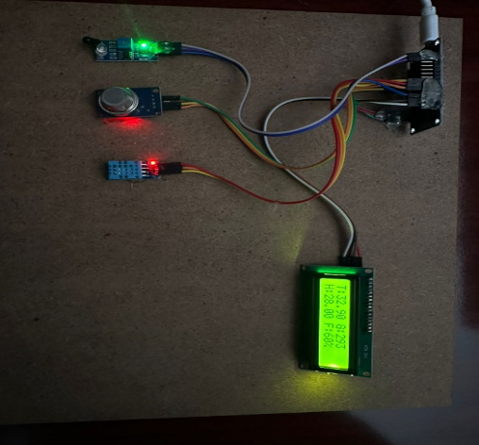
Fig 6.1 Transmitter
- Emergency vehicle alerts (e.g., ambulance, fire truck, police car)
- Road weather and surface condition data
- Vehicle-to-pedestrian (V2P) and vehicle-to-infrastructure (V2I) communication
The CAN protocol ensures reliable and efficient communication, with data transmission rates of up to 1 Mbps. The output is typically displayed on in-vehicle infotainment systems or used by advanced driver-assistance systems (ADAS) to enhance safety and driving experience.
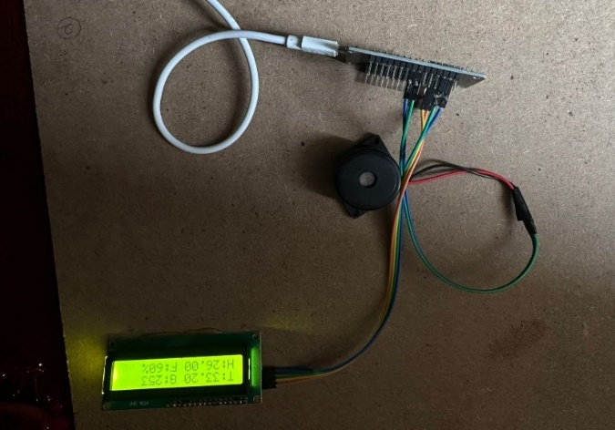
Fig 6.2 Receiver
RESULTS & ANALYSIS:
The results of V2V communication using CAN protocol are far-reaching and impactful:
- Improved road safety: With real-time information sharing, vehicles can anticipate and respond to potential hazards, reducing the risk of accidents and saving lives.
- Enhanced driver convenience: V2V communication enables advanced driver-assistance systems (ADAS) to provide more accurate and timely warnings, improving driver confidence and comfort.
- Optimized traffic flow: With real-time traffic information, vehicles can adjust their speed and trajectory to reduce congestion and improve traffic flow.
- Reduced traffic congestion: V2V communication helps prevent accidents, reduces traffic jams, and optimizes traffic signal timing, leading to reduced congestion and travel times.
- Improved air quality: By reducing congestion and optimizing traffic flow, V2V communication can lead to reduced fuel consumption and lower emissions, improving air quality.

CONCLUSION :
Our field test results on the Dedicated Short-Range Communications (DSRC)-based Vehicle-to-Vehicle (V2V) system in congested environments present a pivotal milestone in automotive safety and communication technology. Adhering to the stringent SAE J2945/1 standard for V2V minimum performance requirements, our tests offer comprehensive validation at the vehicle level for the congestion control protocol. Furthermore, they demonstrate the system's remarkable capability to track vehicle positions with exceptional accuracy, maintaining alignment with ground truth positions within a mere 1.5 meters, even when faced with Inter-Transmit Time (ITT) intervals of 600 milliseconds.
The significance of these findings lies in their implications for active safety and crash avoidance. Congested environments pose unique challenges to V2V communication systems, including increased interference and congestion-induced delays. Despite these obstacles, our DSRC-based V2V system showcases robust performance, ensuring reliable communication and precise positioning of vehicles. By meeting the rigorous standards set by SAE, our system underscores its readiness for deployment in real-world scenarios where safety is paramount. Effective congestion control is essential for optimizing traffic flow and mitigating the risk of accidents in dense traffic conditions. Our tests confirm the efficacy of the congestion control protocol integrated into our V2V system, demonstrating its ability to facilitate smooth and efficient communication among vehicles even in highly congested environments. This capability not only enhances safety but also lays the foundation for intelligent transportation systems capable of dynamically adapting to changing traffic conditions.
Furthermore, the ability to track vehicle positions with high accuracy is critical for enabling a wide range of safety applications, including collision avoidance and lane departure warnings. Our system's ability to maintain alignment with ground truth positions within 1.5 meters ensures reliable data for these applications, enhancing their effectiveness in preventing accidents and reducing the severity of collisions.

FUTURE SCOPE :
The future scope of Vehicle-to-Vehicle (V2V) communication using CAN protocol is promising, with potential applications in:
- Autonomous vehicles: V2V communication will play a crucial role in enabling autonomous vehicles to share data and coordinate actions, ensuring safe and efficient operation.
- Advanced driver-assistance systems (ADAS): V2V will enhance ADAS capabilities, such as collision avoidance, lane departure warning, and adaptive cruise control.
- Smart traffic management: V2V data will be used to optimize traffic signal timing, reducing congestion and travel times.
- Vehicle platooning: V2V will enable vehicles to form platoons, reducing wind resistance and improving fuel efficiency.
- Emergency vehicle communication: V2V will prioritize emergency vehicle passage, reducing response times and improving public safety.
- Vehicle-to-infrastructure (V2I) integration: V2V will be integrated with V2I to enable vehicles to communicate with infrastructure, such as traffic lights and road signs.
- 5G network integration: V2V will leverage 5G networks for faster data transmission rates and lower latency, enabling more advanced applications.
- Autonomous parking and valet services: V2V will enable vehicles to communicate with parking infrastructure, facilitating autonomous parking and valet services.
_ Vehicle-to-pedestrian (V2P) and vehicle-to-cyclist (V2C) communication_: V2V will be extended to communicate with vulnerable road users, improving safety and mobility.
As the automotive industry continues to evolve, V2V communication using CAN protocol is expected to play a vital role in shaping the future of transportation, with potential applications in safety, efficiency, and convenience.
REFERENCES
[1] “Toyota and Lexus to launch technology to connect vehicles and infrastructure in the U.S. in 2021,” accessed: April 16, 2018. [Online]. Available: http://corporatenews.pressroom.toyota.com/releases/toyotaand-lexus-to-launch-technology-connect-vehicles-infrastructure-in-u-s2021.htm
[2] “Cadillacs CTS sedans can now talk to each other, which may make driving way less deadly,” accessed: March 9, 2017. [Online]. Available: https://www.theverge.com/2017/3/9/14869110/cadillac-ctssedan-v2v-communication-dsrc-gm
[3] “VW will offer V2X wireless in Europe by 2019,” accessed: March 9, 2017. [Online]. Available: https://www.theconnectedcar.com/
[4] K. A. Hafeez, L. Zhao, B. Ma, and J. W. Mark, “Performance analysis and enhancement of the dsrc for vanet’s safety applications,” IEEE Transactions on Vehicular Technology, vol. 62, no. 7, pp. 3069–3083, 2013.
[5] A. Rostami, B. Cheng, G. Bansal, K. Sjoberg, M. Gruteser, and J. B. ¨ Kenney, “Stability challenges and enhancements for vehicular channel congestion control approaches,” IEEE Transactions on Intelligent Transportation Systems, vol. 17, no. 10, pp. 2935–2948, 2016.
[6] SAE International, “On-board system requirements for V2V safety communications,” Technical Report Society of Automotive Engineering, 2016.
[7] R. Chen, W.-L. Jin, and A. Regan, “Broadcasting safety information in vehicular networks: issues and approaches,” IEEE network, vol. 24, no. 1, 2010.
[8] H. Hartenstein and L. Laberteaux, “A tutorial survey on vehicular ad hoc networks,” IEEE Communications magazine, vol. 46, no. 6, 2008.
[9] P. Gupta and P. R. Kumar, “The capacity of wireless networks,” IEEE Transactions on information theory, vol. 46, no. 2, pp. 388–404, 2000.
[10] C. Campolo and A. Molinaro, “Multichannel communications in vehicular ad hoc networks: a survey,” IEEE Communications Magazine, vol. 51, no. 5, pp. 158–169, 2013.
[11] A. Weinfield, J. B. Kenney, and G. Bansal, “An adaptive DSRC message transmission rate control algorithm,” in 18th ITS World CongressTransCoreITS AmericaERTICO-ITS EuropeITS Asia-Pacific, 2011.
[12] C.-L. Huang, Y. P. Fallah, R. Sengupta, and H. Krishnan, “Adaptive intervehicle communication control for cooperative safety systems,” IEEE network, vol. 24, no. 1, 2010.
[13] M. Torrent-Moreno, J. Mittag, P. Santi, and H. Hartenstein, “Vehicleto-vehicle communication: fair transmit power control for safety-critical information,” IEEE Transactions on Vehicular Technology, vol. 58, no. 7, pp. 3684–3703, 2009.
[14] T. Tielert, D. Jiang, Q. Chen, L. Delgrossi, and H. Hartenstein, “Design methodology and evaluation of rate adaptation based congestion control for vehicle safety communications,” in IEEE Vehicular Networking Conference (VNC). IEEE, 2011, pp. 116–123.
[15] K. S. Nwizege, F. M. Good, A. Taneh, and S. Neenwi, “Performance analysis of adaptive rate mechanism for ieee 802.11p in DSRC for road safety application in vehicular networks,” in Third International Conference on Computational Intelligence, Modelling and Simulation (CIMSiM). IEEE, 2011, pp. 362–366.

